

Project Report

On

Face Mask Detection System using Python

Submitted to

Amity University, Ranchi (Jharkhand)



*Inpartial fulfillment of therequirements forthe awardof thedegree of*

*Bachelor of Science in Information Technology*

By

Sonali

Enrollment No–A35404918002

*Under the guidance of* ***Ms.LaxmiKumariPathak***

**AMITY INSTITUTE OF INFORMATAION TECHNOLOGY, RANCHI**

**AMITY UNIVERSITY, RANCHI (JHARKHAND)**

**MAY, 2021**

***DECLARATION***

I, **Sonali**, student of **Bachelor of Science in Information Technology** hereby declare that the Project titled **“Face Mask Detection System using Python”** which is submitted by me to Computer Science and Information Technology Department, Amity Institute of Information Technology, Amity University, Ranchi (Jharkhand), in partial fulfillment of requirement for the award of degree of Bachelor of Computer Applications, has not been previously formed the basis for the award of any degree, diploma or other similar title or recognition. I further declare that report is written by me and no part of the report is copied from any source(s) without being duly acknowledged. If it is found to be plagiarized beyond acceptable limit, I owe the responsibility and action can be taken against me as per University Rules & Regulations.

Amity University, Ranchi (Jharkhand)

Date: 16/4/2021



Sign.of the Student

Name of Student: Sonali

Enrollment Number: A35404918002

Semester: 6

Batch: 2018-2021

CERTIFICATE

On the basis of Project Report submitted by **Sonali**, student of **Bachelor of Science in Information Technology**, I hereby certify that the Project Report **“Face Mask Detection System using Python”** which is submitted to Computer Science and Information Technology Department, Amity Institute of Information Technology, Amity University, Ranchi (Jharkhand)in partial fulfillment of requirement for the award of the degree of Bachelor of Computer Application is an original contribution with existing knowledge and faithful record of work carried out by him/her under my guidance and supervision.

To the best of my knowledge this work has not been submitted in part or full for any Degree or Diploma to this University or elsewhere.

Amity University, Ranchi (Jharkhand)

Date: 16/4/2021

Signature ofGuide(Internal)

Ms. LaxmiKumariPathak

Assistant Professor

Amity Institute of Information Technology, Ranchi

Amity University, Ranchi (Jharkhand)

***ACKNOWLEDGEMENT***

*I express my sincere gratitude to my faculty guide* ***Ms.LaxmiKumariPathak*** *for her able guidance, continuous support and cooperation throughout my project, without which the present work would not have been possible. My endeavor stands incomplete without dedicating my gratitude to her; she has contributed a lot towards successful completion of my project work.*

*I would like to acknowledge my indebtedness and deep sense of gratitude to my Program Coordinator,* ***Dr.BiswarupSamanta****, and Program Leader,* ***Dr.PoojaJha*** *to encourage me to the highest peak and to provide me the opportunity to prepare the project.*

*I would also like to express my sincere thanks towards my family and friends for their unending support, and tireless effort that kept me motivated throughout the completion of this project.*

*Yours Sincerely*

*Name of the Student: Sonali*

*Enrollment Number: A35404918002*

*Semester: 6*

*Batch: 2018-2021*

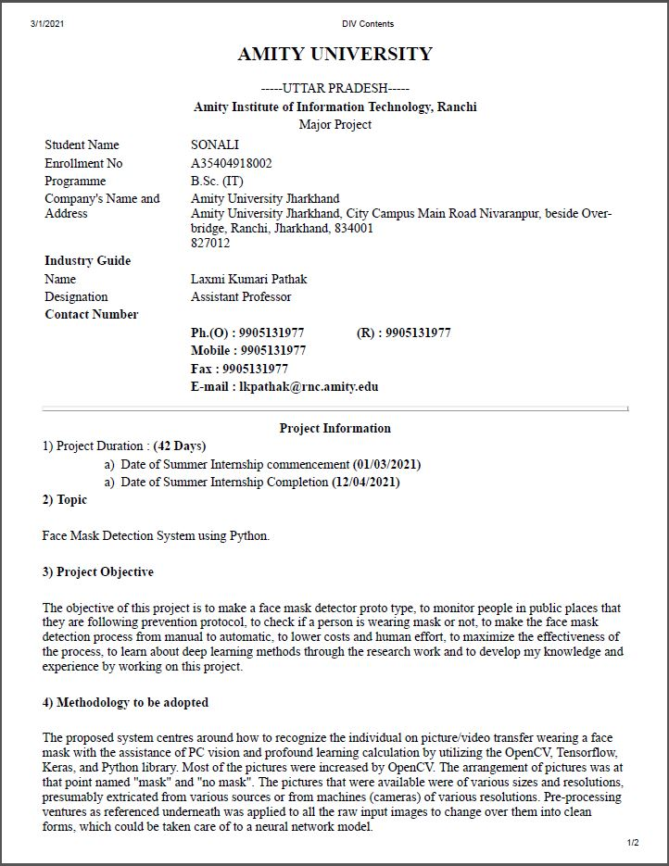

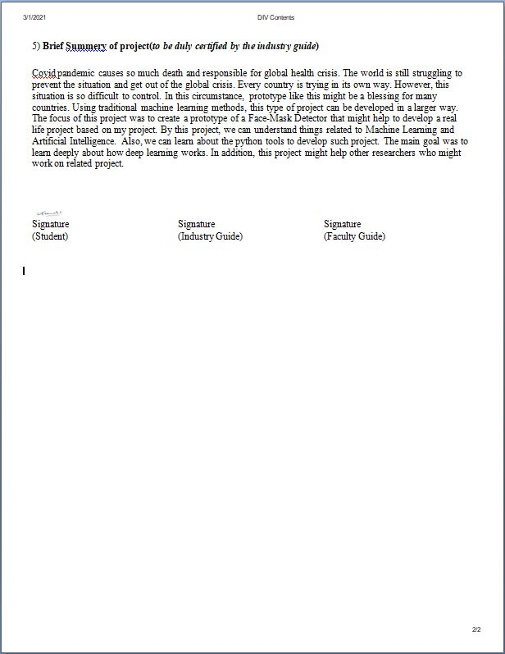

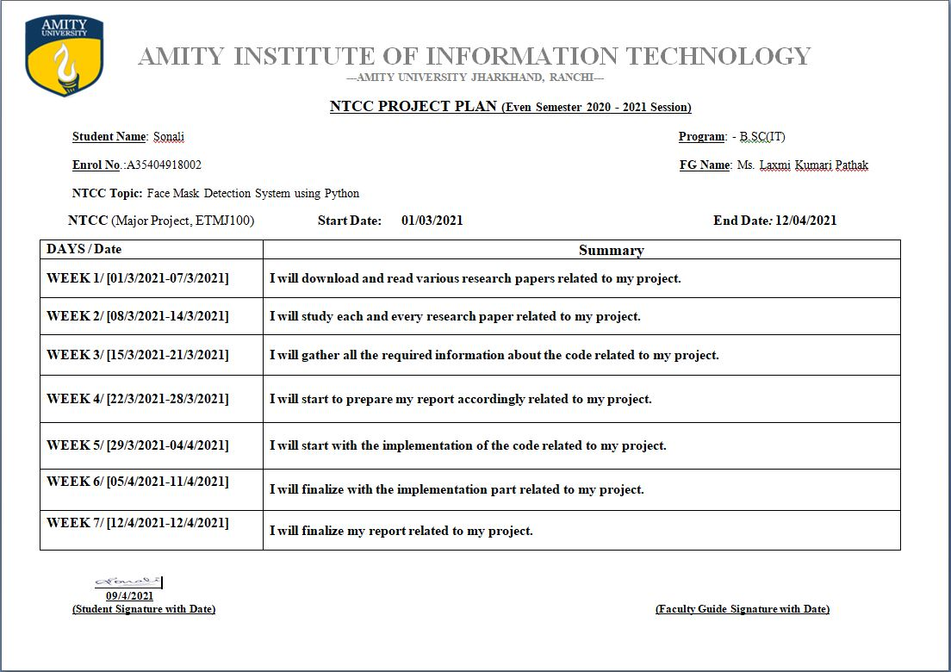

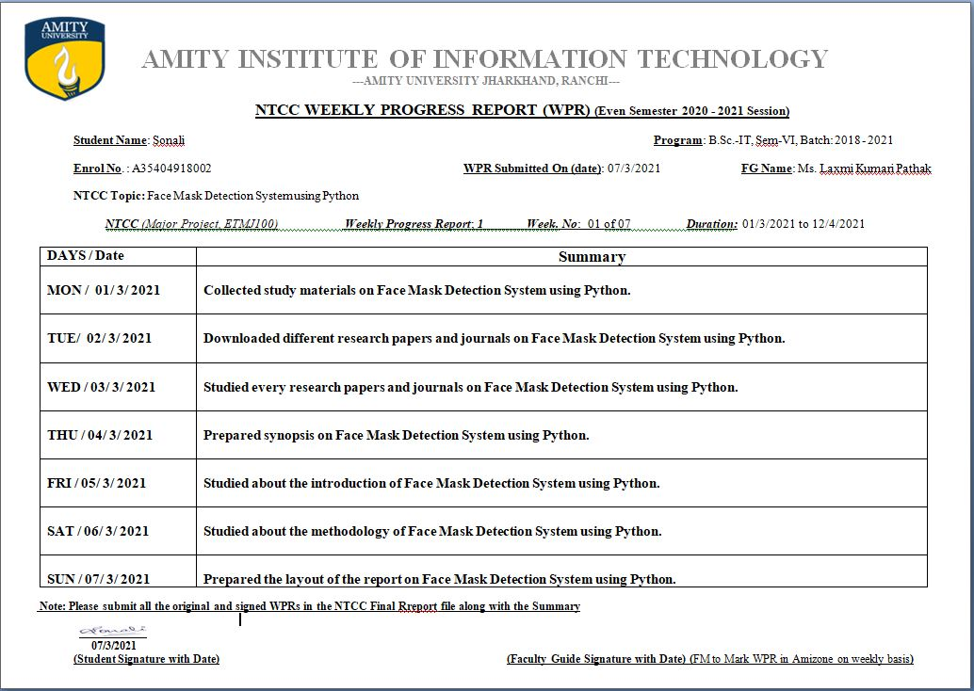

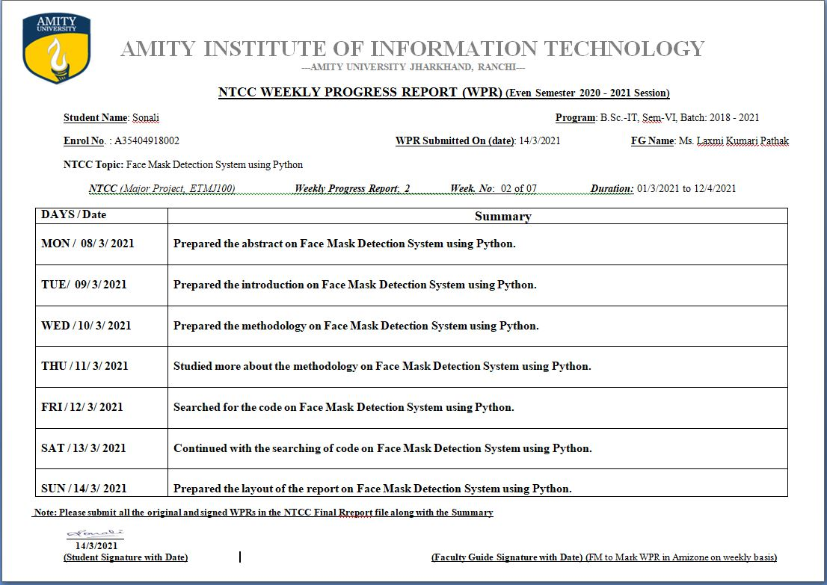

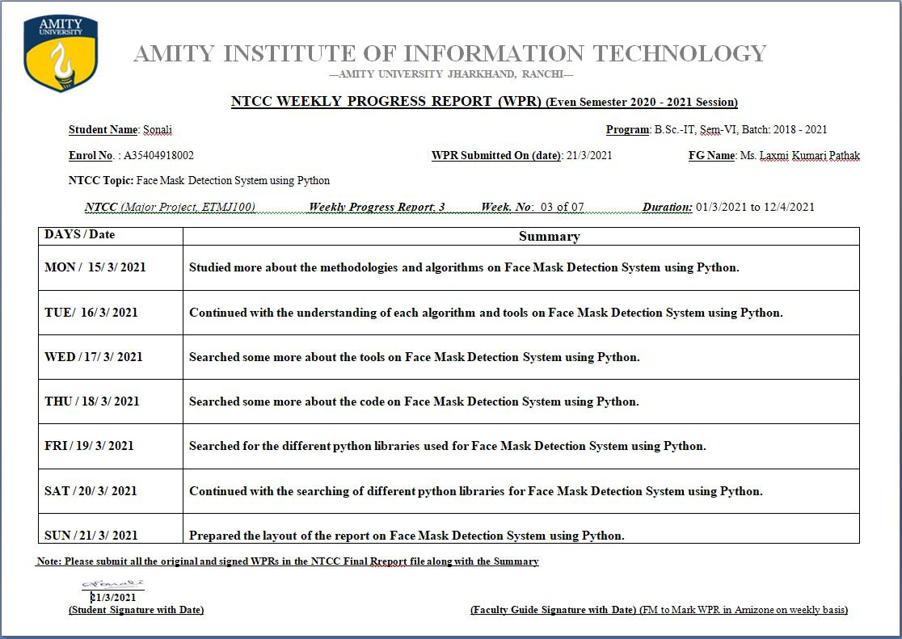

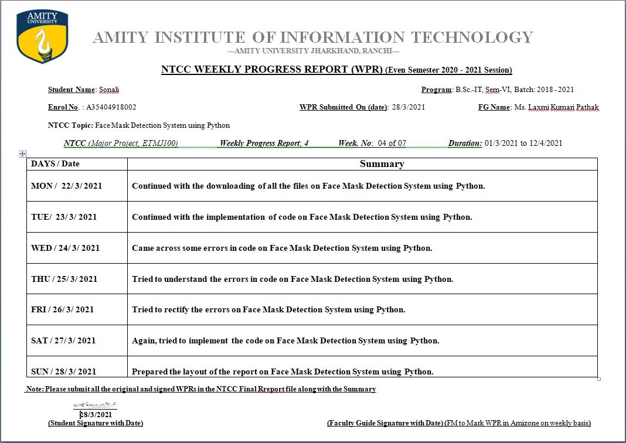

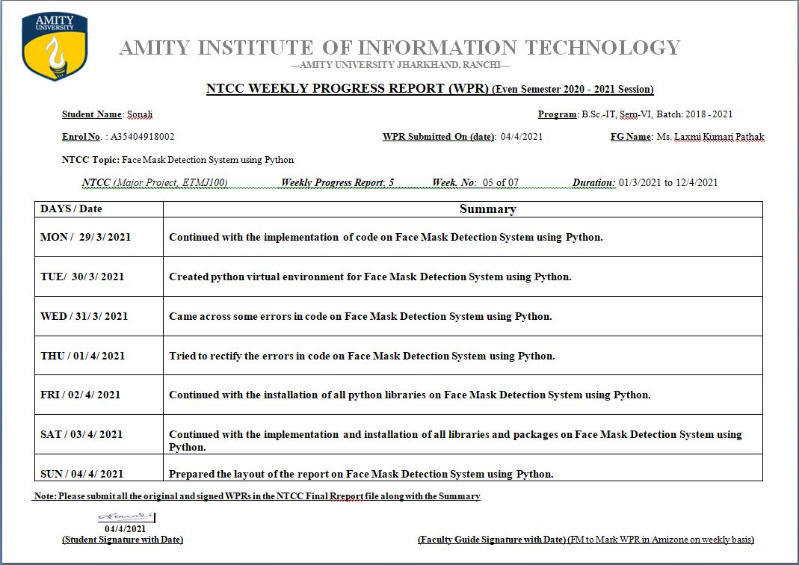

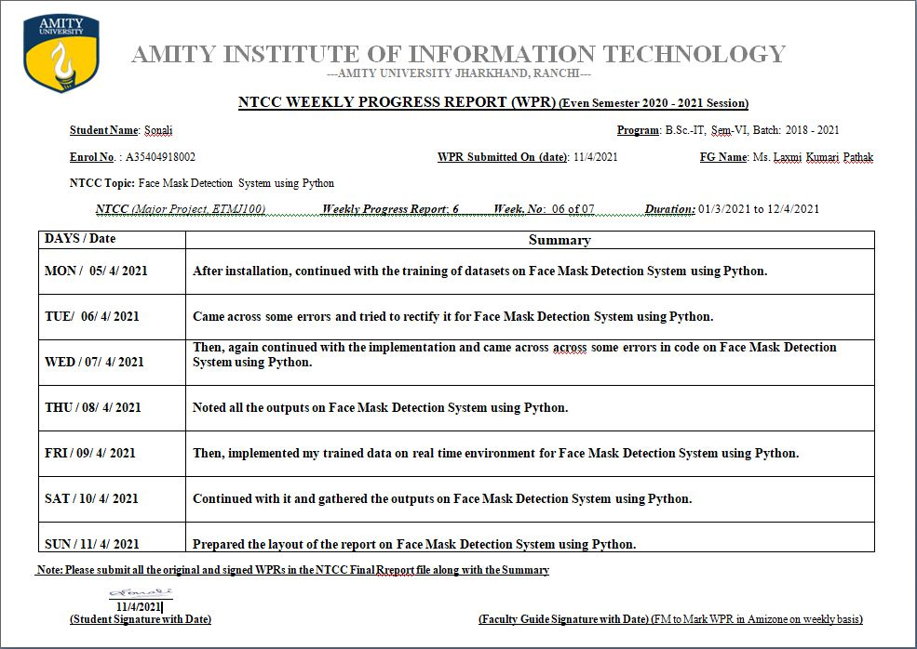

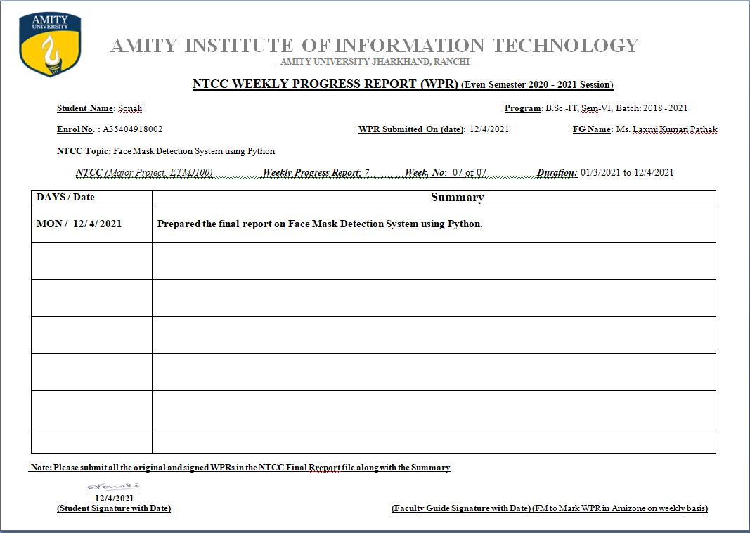

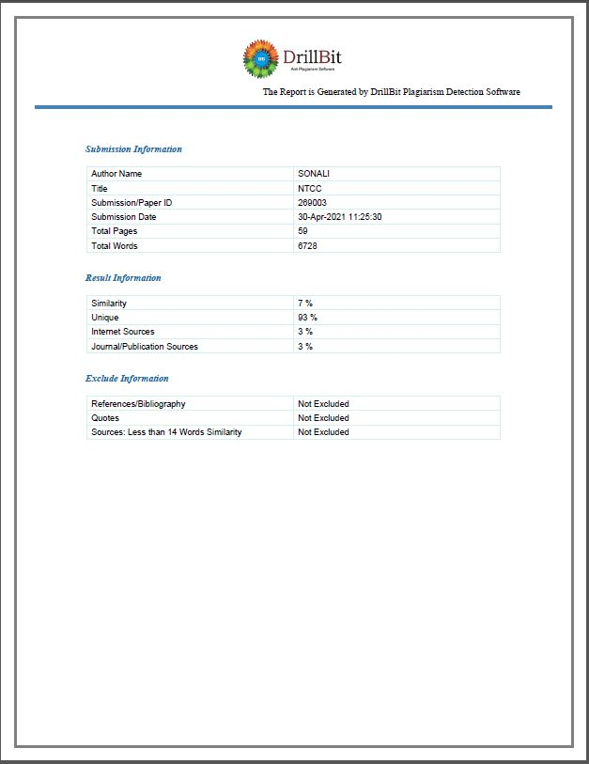

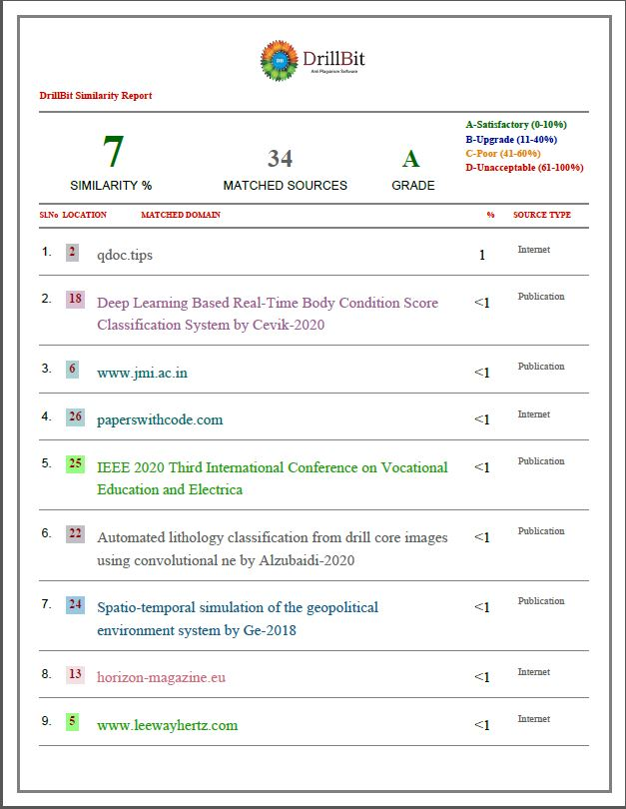

**Preliminary Pages**

* Cover Page
* Declaration by Scholar
* Certified copy of Originality of Work
* Acknowledgment by Scholar
* Certified Synopsis
* Certified Project Plan
* Certified WPR Chart
* Certified Plagiarism Report
* Main Report

**List of Contents (Main Text)**

List of tables

List of figures

**1. Introduction**

* 1. Definition of the key terms----------------------------------------------------------1-4
  2. Literature Review---------------------------------------------------------------------4-5
  3. Scope of the study---------------------------------------------------------------------5
  4. Advantages of Face Mask Detection------------------------------------------------6

1.5 Disadvantages of Face Mask Detection--------------------------------------------6

1.6 Proposed Work------------------------------------------------------------------------6-7

**2. Research Methodology**

2.1 Introduction----------------------------------------------------------------------------7

2.2 Data Sets and Data Types------------------------------------------------------------7-8

2.3 Research Design-----------------------------------------------------------------------9

2.4 Data Analysis Plan--------------------------------------------------------------------10

**3. Data Analysis**

3.1 Installing the dependencies---------------------------------------------------------10-15

3.2 Data Preprocessing-------------------------------------------------------------------16-18

3.3 Train Model----------------------------------------------------------------------------19-24

3.4 Implementation-----------------------------------------------------------------------25-31

3.5 Result-----------------------------------------------------------------------------------32-33

3.6 Final Result----------------------------------------------------------------------------33

**4. Findings, Conclusion & Recommendations**

4.1 Conclusion ---------------------------------------------------------------------------35

4.2 Recommendations-----------------------------------------------------------------35

**5. Appendix & Bibliography**

5.1 References--------------------------------------------------------------------------36-38

**LIST OF FIGURES**

1. Convolutional Neural Network-----------------------------------------------3
2. With Mask Dataset-------------------------------------------------------------8
3. Without Mask Dataset---------------------------------------------------------8
4. Research Design----------------------------------------------------------------9
5. Installing the Dependencies(1)-----------------------------------------------10
6. Installing the Dependencies(2)-----------------------------------------------11
7. Installing the Dependencies(3)-----------------------------------------------11
8. Installing the Dependencies(4)-----------------------------------------------12
9. Installing the Dependencies(5)-----------------------------------------------12
10. Installing the Dependencies(6)-----------------------------------------------13
11. Mask Detector Model---------------------------------------------------------16
12. Setting Directories and Categories and Looping Them--------------------17
13. Encoding Labels---------------------------------------------------------------18
14. Setting Initial Learning Rate, Epochs and Batch Size---------------------19
15. Data Augmentation and Creating Base Model-----------------------------20
16. Creating Head Model and Looping Based Model-------------------------21
17. Compiling Head and Base Model and Fitting the Model-----------------22
18. Making Predictions on the Testing Set-------------------------------------23
19. Developing Codes to Plot Model------------------------------------------24
20. Compilation Screen for Training_Script of Face Mask Detection-----32
21. Training Loss/Accuracy Curves of Face Mask Detection Dataset-----32
22. Face Mask Classifier Performance Metrics------------------------------33
23. Detect Face With Mask in Image-----------------------------------------34
24. Detect Face With Mask in Real Time Video Stream--------------------35
25. Detect Face Without Mask in Real Time Video Stream----------------35

**ABSTRACT**

Covid-19 or the Corona virus pandemic is the biggest challenge faced by the world today. The pandemic has spread widely bringing the world to a hault and the number of cases continued to rise. Governments all around the world are working to slow down, if not completely stopped the spread of this pandemic. They implemented many a protocols and one very crucial one was wearing a mask. The world has been fighting with pandemic with great spirit. In India also, the unlocking phases are already in motion. They need to be pro-active now is more than ever and the governments all around the world recognize the power of Artificial Intelligence and Machine Learning in-order-to fight the pandemic. Now, since wearing a mask and avoiding crowded places is the only alternative until a solid vaccine is introduced in the mainstream market, computer vision in the form of mask detection can be a reviving factor to get life back to normal. Real-time mask detection can solve the monitoring issues in countries like ours with large population. As we all know, covid-19 has been impacting many industries, atleast 100 million people have lost their jobs in India, more than 30 million fresh graduates out of campus are unemployed, global lockdown and quarantine have taken a toll on peoples’ physical and mental health and employers are also struggling to provide infrastructure for smooth transition, and in-order-to revive the economies, the businesses and workplaces must open with proper functioning but for that we need to take some safety measures which must be enforced for safety of general public and employees alike, which are social distancing and mask culture.

1. **INTRODUCTION**

Covid disorder (COVID-19) is an overwhelming pollution accomplished by an as of late found Novel Corona Virus Disease-19(Covid - 19). Covid causes respiratory disillusionments including injury of the heart liver, and kidneys, and its leadings to death. Most by a wide margin ruined with the Coronavirus infections will encounter fragile to arrange respiratory hardship and recuperate without requiring extraordinary treatment. For this explanation, one should close a face with veil. The guideline inspiration driving wearing a facial cover is to stop the spreading of the contamination through globules that are coming out while talking, sneezing, or hacking. WHO (World Health Organization) has urged different nations to guarantee that their occupants are wearing face veil out in the open spots. With the help of AI, it is shown that we can perceive face and outward appearances.

Here we present a distinguishing of face veil model that relies upon PC vision and profound learning. The proposed model can be fused with perception cameras to impede the COVID-19 transmission by allowing the distinguishing proof of people who are wearing face veils not wearing a facemask. The model is a blend profound learning and customary AI methods with the tensor stream, Keras, and OpenCV.

There is expanding utilization of PC vision for reconnaissance, face identification and other constant perceptions. The reason for the PC vision is to destroy the human intercessions in the perceptions and supplant them with the PC eye. The excellent advantage which happens through this is the expanded exactness and accuracy in identification which an ordinary natural eye can't catch at times. Subsequently, by sending a PC vision we can distinguish an individual and examine him.

This is the continuous season of the COVID-19 pandemic. It has gotten totally vital for individuals to wear veils when they go out, particularly when they go to a spot which has the capability of becoming busy. It turns into a provoking undertaking to screen a gathering of individuals. On the off chance that a few people wander without a cover, they can turn into an inception of spreading COVID19 to different people which chances others' lives.

To beat this burdensome and testing task, the arrangement is to put fake reconnaissance which can constantly screen a gathering of individuals. To achieve this undertaking, we need a framework that can recognizethe face of individuals from the picture caught. From these perceived faces, we need to identify if there is a cover worn. A couple of profound learning models exist which can be utilized for face-location. Be that as it may, they need terms of precision. Henceforth to accomplish this objective, we have utilized ResNet-101. We sent this model on the RaspberryPI board and incorporated a web camera to catch pictures. The framework developed here by us can catch constant pictures and from that pictures identify if individuals have worn a cover.

**1.1 DEFINITION OF THE KEY TERMS**

**1.1.1 PYTHON PROGRAMMING LANGUAGE**

Python is an undeniable level programming language. It is quite possibly the most mainstream programming language in light of the accompanying

• Ease of utilization/User cordiality

• Fast to create

• Open source language

• Has an extraordinary local area

• Vast measure of libraries and bundles

• Probably the best for making models

• Good for information investigation and representation additionally for AI based profound

learning

Rather than having such benefits, it has likewise a few limits as underneath

• Case Sensitive

• Slower than different dialects

• Not so valuable in portable climate

**1.1.2 DEEP LEARNING**

It is a part of AI. Using deep learning model, we can make machine work for us. Machine can work like a human but more effectively and more errorless. Because machine can work without any rest. A machine goes through many trial and error processes to complete a model. So, there are less probability to have error from machine. By using deep learning, we can make machine imitating human activities.

**1.1.3 CONVOLUTIONAL NEURAL NETWORK**

CNN or ConvNet is a class of deep learning or deep neural network. It is used for analyzing visual imagery. It is similar to a traditional ANN. It is self-optimized through learning. It is used for pattern recognition of images. As, it is a face mask detection model, CNN helped it to detect special pattern of mask from the dataset it has used.

**

FIG.1: CONVOLUTIONAL NEURAL NETWORK

**1.1.4 FACE MASK DETECTOR**

To develop a face mask detector, two developing two individual detector is necessary. Firstly, we need to develop a mask detector model individually and a face detector model individually. Then we need to combine both of them in a separate file, which will finally create a face mask detection prototype. Luckily, a vast amount of face detector model is available online. So, we only need to have a mask detector model.

**1.1.5 ARTIFICIAL INTELLIGENCE**

Analysts are attempting to make machine think without anyone else with the assistance of AI. Man-made intelligence is utilized for advanced mechanics. It is one of the sub space of AI. Simulated intelligence can likewise be utilized in clinical field. Eugene Charniak notice that AI is the investigation of intellectual capacities utilizing computational models. Man-made intelligence alludes to give knowledge to the machine with the goal that it can act like human, take care of issue utilizing its own insight.

**1.1.6 MACHINE LEARNING**

AI is a technique for AI to decide for PC vision, controlling robot, and discourse and face acknowledgment, etc. Numerous AI designers consider that train a framework by showing it models is simpler than doing it physically. There is a wide scope of AI in the field of software engineering. AI is fueling up the advanced society. Numerous areas, for example, online business, web engineer, long range interpersonal communication and a lot more are getting the gifts of AI. It assists with distinguishing objects from pictures, perceiving discourse, etc.

* 1. **LITERATURE REVIEW**

Sriman Mitra[1] centers to make a model of a Face-Mask Detector that may assist with building up a genuine undertaking dependent on the venture. The creator attempted to accomplish the most noteworthy exactness conceivable in the model. By this task, it can assist with understanding things identified with Machine Learning and Artificial Intelligence. Likewise, it can help in finding out about the python devices to grow such undertaking. The primary objective was to adapt profoundly about how profound learning functions. Likewise, this undertaking may help different scientists who may chip away at related task.

Karthik Srivathsa D S et. Al.[2] shares that as the development is blooming with emerging examples the availability, it has a face cover identifier which can add to public open spots. The plan incorporates the mobilenet as the spine it can likewise be utilized in high and low assessment conditions to isolate all the more remarkable features, it utilizes move sorting out some way to change loads from a tantamount task face identification, which is set up on an outstandingly enormous dataset. It used OpenCV, tensorflow, keras, Python and CNN to recognize if people were wearing face veil. The models were tried with pictures and consistent video moves. This specific model could be used as a usage case for edge assessment. Besides, the proposed procedure achieves forefront results on a public face veil dataset. By the headway of face veil acknowledgment, it can recognize if the individual is wearing a face cover, and license their passageway would be of fantastic help to society.

Harsh Nagoriya and Mohak Parekh[3] shares that in the current COVID emergency, it has gotten vital for wear a facemask. Wearing it, the spreading of the infection is by all accounts diminishing. Henceforth, to deal with this dreary occupation of checking if an individual has worn a veil, a robotized framework was created in this examination project. A definitive objective and the finish of the undertaking were to facilitate a few partners, who will give a superior knowledge into the group visiting at their place. The dataset has probed different calculations and methodologies. The examination intended to acquire the most extreme exactness for the proposed framework. The current work reasoned that the ResNet-101 model comprising of 101 lingering layers, empowered the framework to reach to a superior precision score of 96.02%. Subsequently, utilizing the profound exchange learning and the RaspberryPI, the framework accomplished assignment mechanization which doesn't need human intercession.

Moein Razavi et. Al.[4] built up a model to recognize face veil wearing and physical removing among development laborers to guarantee their security in the COVID-19 pandemic. The paper discovered a facemask dataset incorporating pictures of individuals with veil, without cover, and wrong veil wearing. To build the preparation dataset, 1,000 pictures with various sorts of cover wearing were gathered and added to the dataset to make a dataset with 1,853 pictures. A Faster R-CNN Inception ResNet V2 network was picked among various models that yielded the exactness of 99.8% for face veil discovery. For actual distance identification, the Faster R-CNN Inception V2 was utilized to distinguish individuals and a change grid was utilized to eliminate the impact of the camera point on genuine distance. The Euclidian distance changed the pixels of the changed picture over to individuals' genuine distance. The model set an edge of six feet to catch actual distance infringement. Move learning was utilized for preparing models. Four recordings of genuine street upkeep projects in Houston, TX, were utilized to assess the joined model. The yield of the four cases demonstrated a normal of over 90% precision in recognizing various kinds of veil wearing in development workers. Also, the model precisely distinguished laborers who were excessively close and didn't rehearse the physical separating. Street project proprietors and workers for hire can utilize the model outcomes to screen laborers to keep away from contamination and upgrade laborers' security. Future examinations can utilize the model on other development undertakings like structure projects. Likewise, future investigations can attempt other recognition models and tune the hyper boundaries to build the identification precision.

Amrit Kumar Bhadani and Anurag Sinha[5] shares that as the innovation are blossoming with arising patterns the accessibility, it has a novel face veil indicator which can add to general medical services division. The engineering comprises of MobileNetV2 classifier and ADAM analyzer as the spine it tends to be utilized for high and low calculation situations. The face cover recognition is prepared on CNN model and we are utilized Oven CV, Tensor Flow, Keras and python to distinguish if individual is wearing a veil . The model was time video transfer. The precision of model is accomplished and, the improvement of the model is nonstop interaction. This particular model could be utilized as use instance of edge investigation.

* 1. **SCOPE OF THE STUDY**

The current continuous framework is gracing with MobileNetV2 classifier outstanding amongst other framework which would be executed alongside the interface of caution and alarming framework in group of people yet to come. This framework will be coordinated with the framework executing social removing that would make it a total framework which can welcome an emotional effect on the spread of. The new world will be prosperity of appeal of veil as nondescript future and that will be a major security concern. Skill say, CNN that utilizing face veil ends up being the best answer for moderate the spread of air borne infection like crown, yet as a major security concern made a beeline for challenge the country as it would set out a gigantic freedom for individuals who cover their countenances for evil explanation. And furthermore specialists say the mass no of veil wearing in could muddle in wrongdoing examination in the coming days, as facial acknowledgment is a significant part in following of the lawbreakers. At the point when the pandemic Coronavirus getting over, at that point this framework becomes possibly the most important factor for substance processing plants, bank, glass production lines and so on On the off chance that an individual enters the bank while wearing a veil he would be not permitted to enter and furthermore if the individual doesn't wear covers in glass plants compound industrial facilities and so forth then the individual would not be permitted to enter to the business.

A brain idea of person have been demonstrated out to be truly adept at perceiving natural appearances and facial perceiving recognizable countenances and facial acknowledgment calculations are improving in distinguishing design.

So along these lines this test would make an extension to new face identification calculations which can recognize experts which are covered with more noteworthy exactnesses and precisions.

**1.4 ADVANTAGES OF FACE MASK DETECTION**

* This diminishes costs just as human exertion.
* Authorities can screen more individuals distantly by utilizing surveillance

cameras as it were.

* Increasing public mindfulness will be a lot simpler.
* Researcher can notice human conduct towards the pandemic.
* Maximize the adequacy of the cycle.

**1.5 DISADVANTAGES OF FACE MASK DETECTION**

* It isn't feasible for a solitary individual to chip away at an enormous task.
* The model is more modest here as the dataset is more modest.
* Lack of legitimate information in the connected fields.
* The exactness of the model probably won't be the awesome the information is

restricted.

* Lack of assets.
* Lower execution probability as it is an example project.

**1.6 PROPOSED WORK**

The proposed framework base's on the best way to perceive the person on picture/video move wearing a face cover with the help of PC vision and significant learning estimation by using the OpenCV, Tensorflow, Keras, and Python library.

**DATA AT SOURCE**

The majority of the photos were expanded by OpenCV. The course of action of pictures was by then named "cover" and "no veil". The photos that were accessible were of different sizes and goals, probably removed from different sources or from machines (cameras) of different goal

**DATA PRE-PROCESSING**

Pre-handling adventures as referred to under was applied to every one of the crude information pictures to change over them into clean structures, which could be dealt with to a neural organization model.

1. Modifying the size of an embedded picture (256 x 256).

2. Put in the shading Computing (RGB) over the transmission.

3. Scaling/Normalizing pictures using the standard mean of Python work in loads.

4. Focus managing the image with the pixel assessment of 224x224x3.

5. At last change them into tensors.

**STEPS TO FACE MASK DETECTION**

Step1: input face cover dataset

Step2: Train the dataset with python libraries

Step3: revise the dataset to plate

Step4: load dataset from plate

Step5: Detect faces from picture/video transfer

Step6: decide with or without cover

Stage 7: yield the outcome

1. **METHODOLOGIES:**

**RESEARCH METHODOLOGY:**

* 1. **INTRODUCTION**

This venture has been finished with the assistance of AI, absolutely the profound learning strategies. Here I have utilized convolutional neural organization with a slight change. The change is here I have supplanted ConvNet with MobileNet as MobileNet is quicker to create and simple to use for creating model. Despite the fact that utilizing CNN may give me better model, yet it would turn into a tremendous undertaking to grow such model. Likewise, it needs better gadgets to perform well.

**2.2 DATASETS AND DATA TYPES**

Here, I utilized two example as contribution to prepare the machine. The initially set contains various pictures of individuals wearing various kinds of veils. In addition, the other set contains various sorts of without veil pictures. I have attempted to utilize various sorts of pictures to guarantee getting a decent model.

The information I have gathered were clear cut information. Later the information were changed into mathematical information by utilizing python codes. As machine can't deal with straight out information I needed to change them into mathematical. The datasets I have utilized for the exploration design was principally optional information as I have gathered them from outside source. The datasets were gathered from the GitHub record of 'Chandrika Deb'.

There are absolute 1915 pictures in the organizer named 'with_mask'. Additionally, the 'without_mask' organizer contains 1918 pictures. I accept, if the datasets could be better, would have delivered much better model. Sadly, I had constraints of giving datasets as my gadget would not work as expected and may have issue with a colossal task. A brief look at the datasets are appeared beneath:

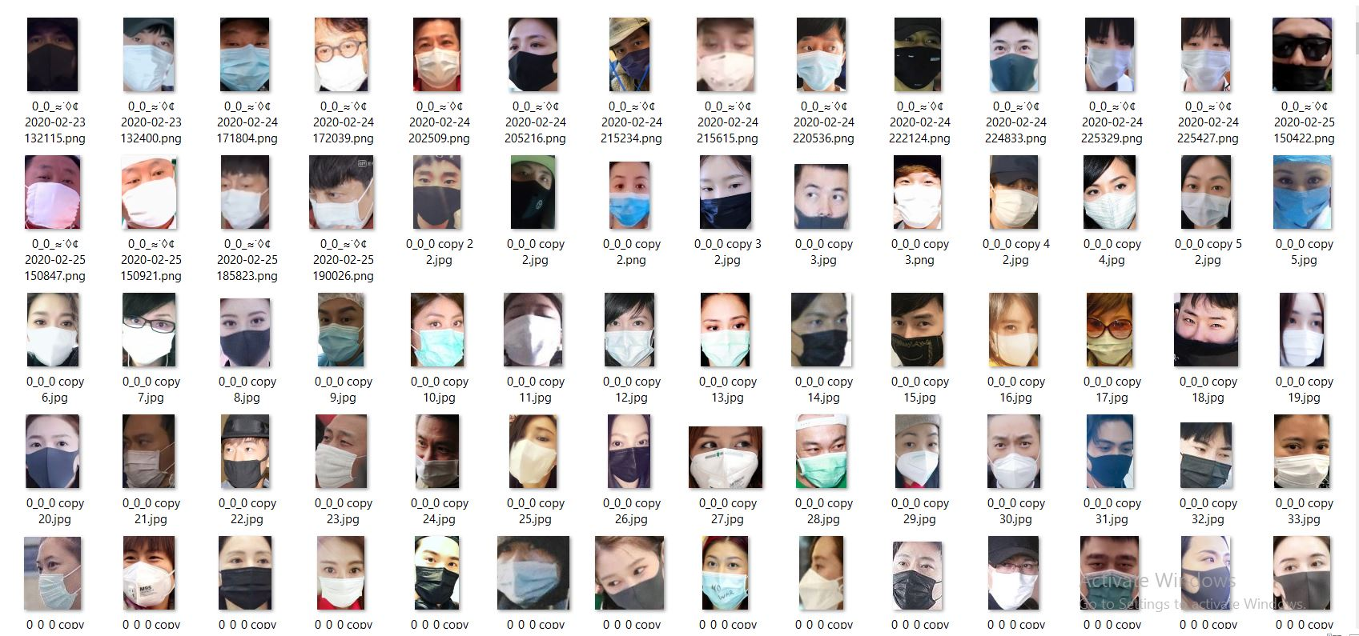

FIG.2: WITH MASK DATASET

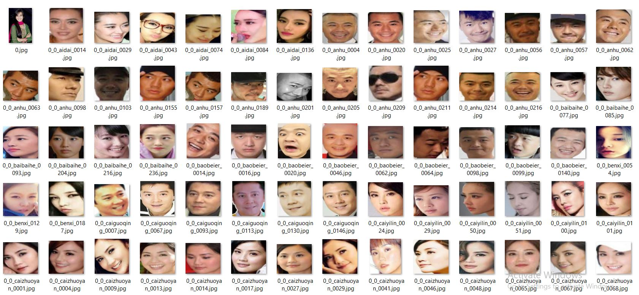

FIG.3: WITHOUT MASK DATASET

**2.3 RESEARCH DESIGN**

This undertaking is really a quantitative exploration. Since I needed to gather information, break down and imagine them with python programming language, train model utilizing the python devices lastly get a yield from a crude info, which can identify veil in human face. Every one of the qualities shows that my paper is really an aftereffect of quantitative exploration. Moreover, this venture is spellbinding exploration as the point of the undertaking is to create model with higher exactness and accuracy. I additionally can call this examination as an exploratory just as an activity research. Planning of this venture can be depicted in a matter of seconds through the accompanying figure.

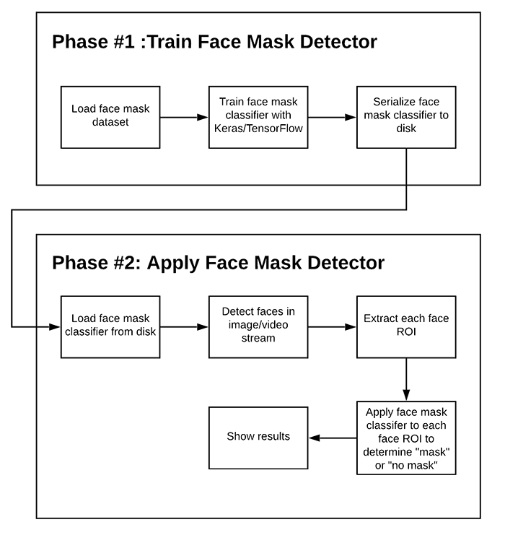

FIG.4: RESEARCH DESIGN

**2.4 DATA ANALYSIS PLAN**

As recently referenced, the datasets contain various sorts pictures separated in two sub-organizer. I utilized Python to dissect information. With the assistance of the information, right off the bat I attempted to prepare machine and build up a veil locator model. At that point I gathered a face finder from on the web (S., 2020). From that point forward, I consolidated both the identifier to create face cover finder. After the advancement is finished, I carry out it into continuous utilizing my PC camera.

1. **RESEARCH ANALYSIS AND DESIGN:**
   1. **INSTALLING THE DEPENDENCIES:**

To build up our model and utilizing the model in the ongoing camera, we first need to introduce the accompanying conditions or python bundles.

i. Tensorflow (version 1.15.2)

ii. Keras (version 1.15.2)

iii. Imutils (version 1.15.2)

iv. Numpy (version 1.15.2)

v. Opencv (version 1.15.2)

vi. Matplotlib (version 1.15.2)

vii. Scipy (version 1.15.2)

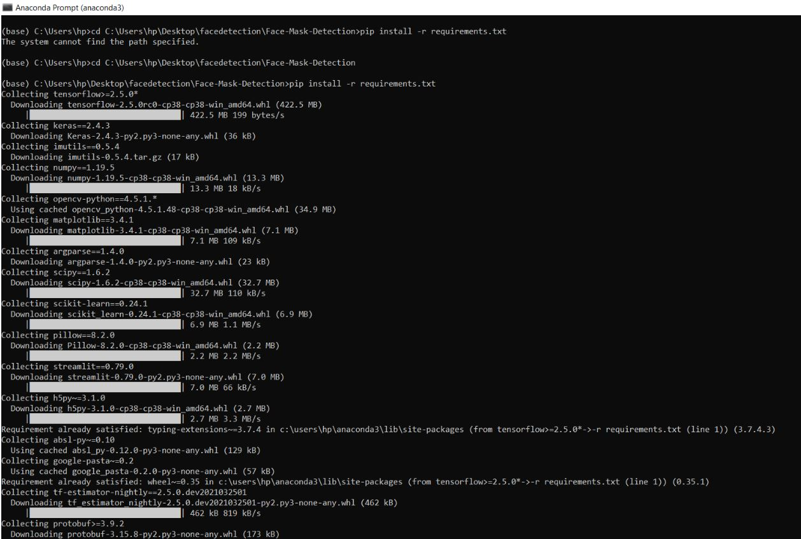

FIG.5: INSTALLING THE DEPENDENCIES(1)

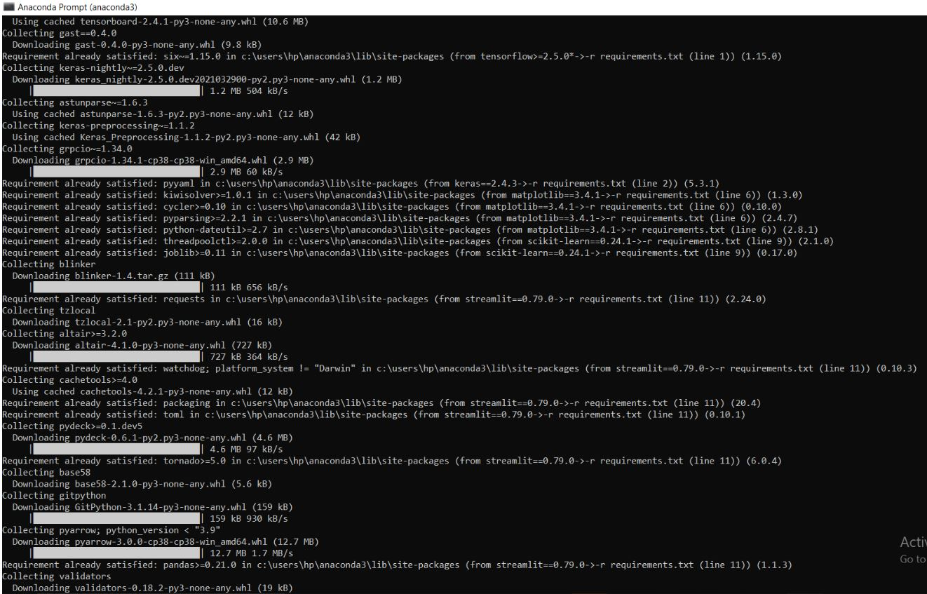

FIG.6: INSTALLING THE DEPENDENCIES(2)

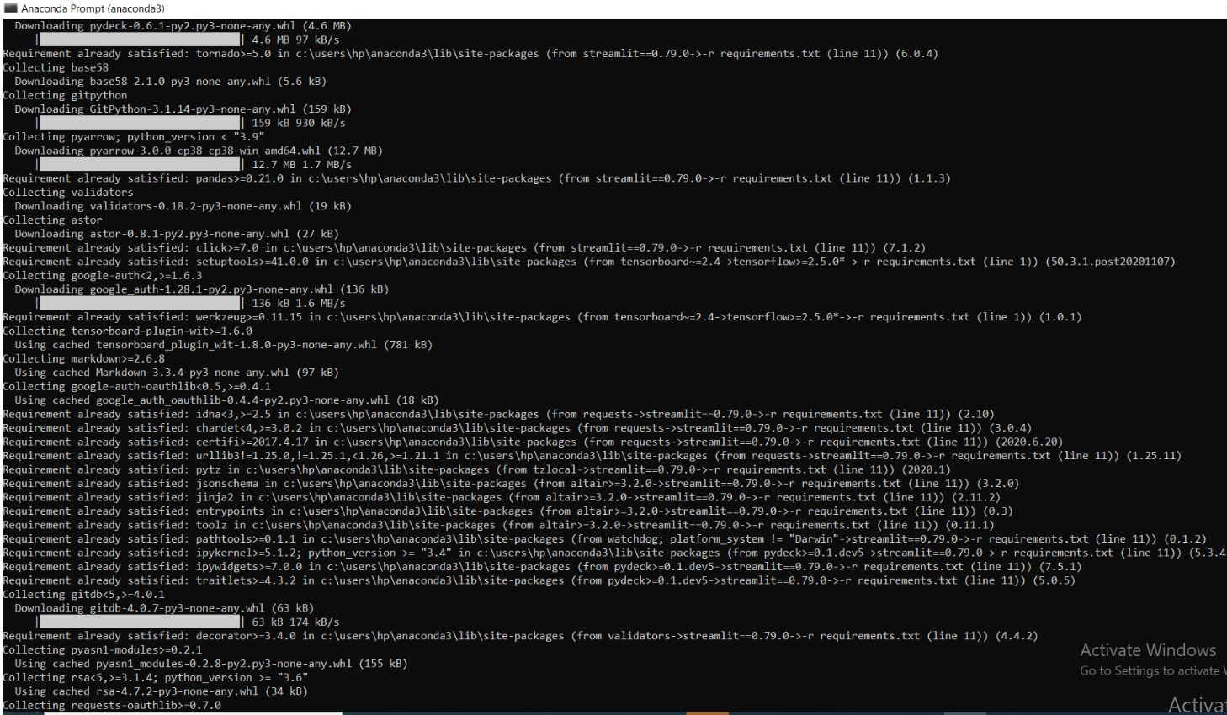

FIG.7: INSTALLING TH E DEPENDENCIES(3)

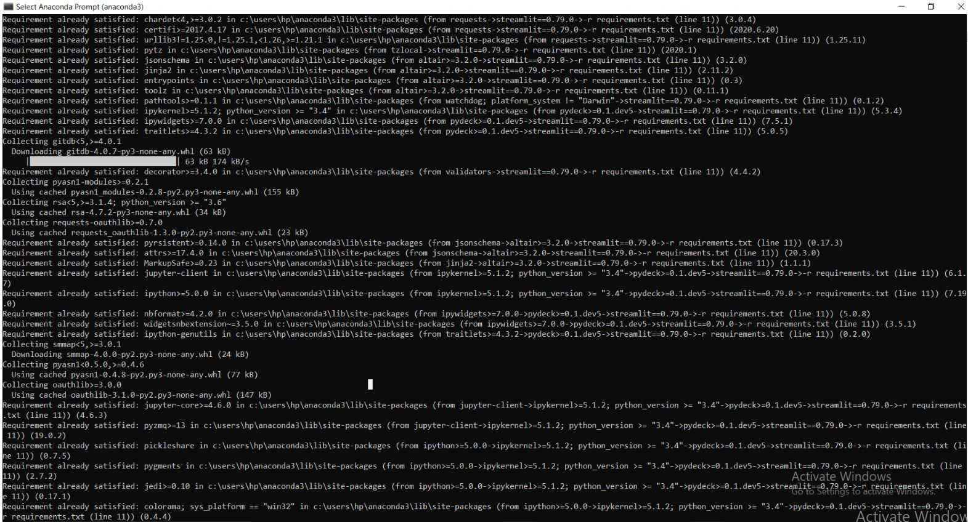

FIG.8: INSTALLING THE DEPENDENCIES(4)

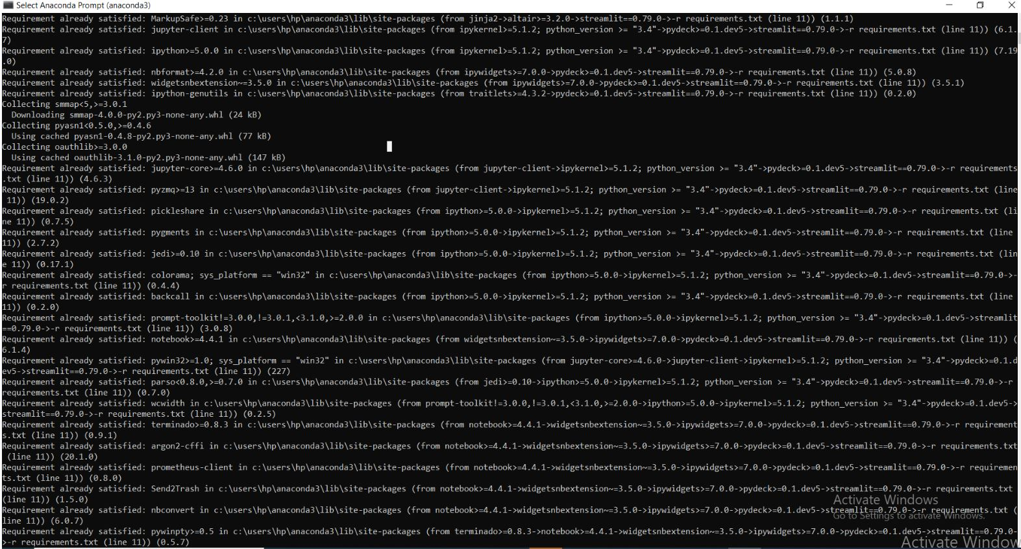

FIG.9: INSTALLING THE DEPENDENCIES(5)

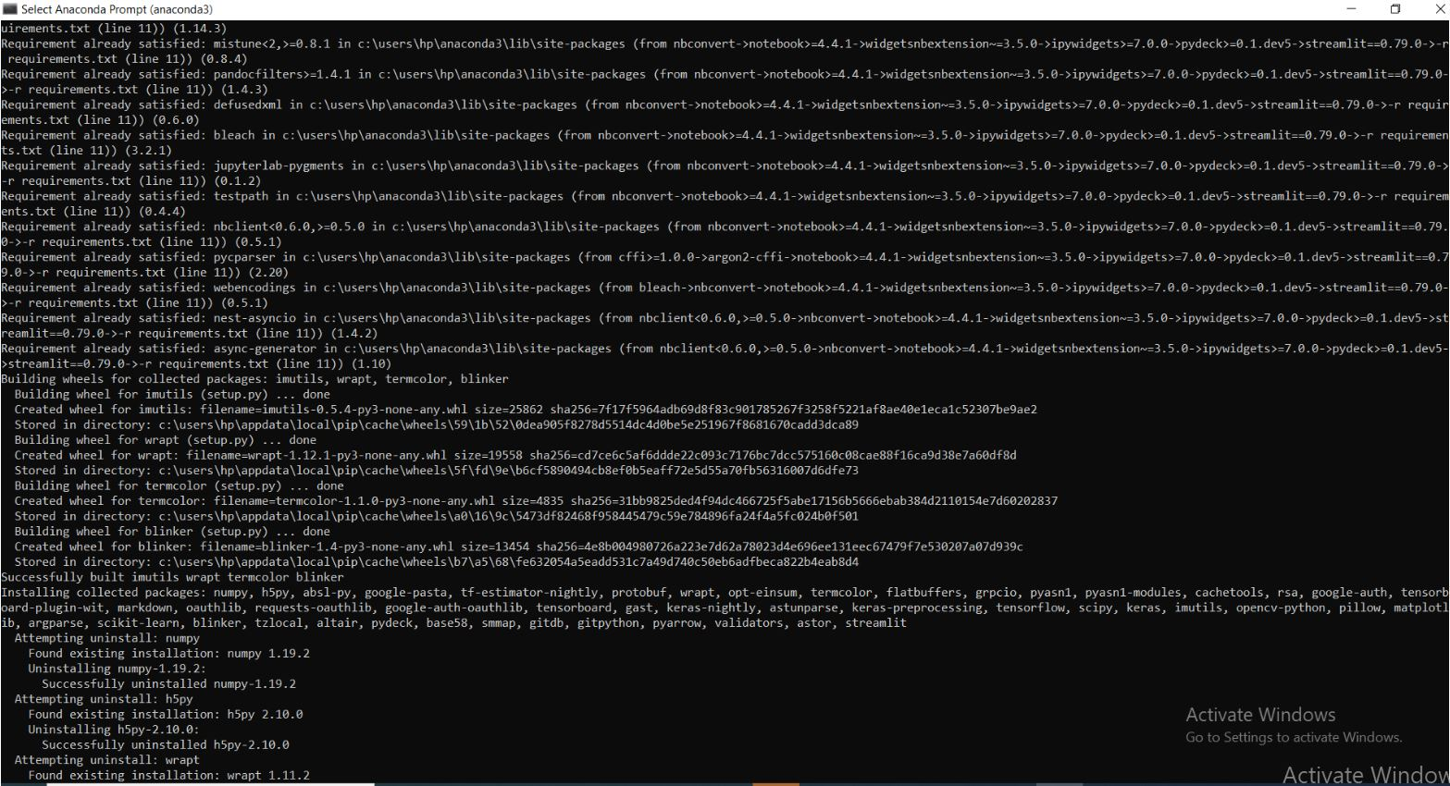

FIG.10: INSTALLING THE DEPENDENCIES(6)

1. **TENSORFLOW:**

TensorFlow is a start to finish open source stage for AI. It has a complete, adaptable biological system of apparatuses, libraries and local area assets that allows scientists to push the cutting edge in ML and designers effectively assemble and send ML fueled applications. It helps in building and preparing ML models effectively utilizing instinctive significant level APIs like Keras with energetic execution, which makes for sure fire model cycle and simple troubleshooting. Likewise, it helps in powerful ML creation as it effectively prepares and deployes models in the cloud, on-prem, in the program, or on-gadget regardless of what language we use. Additionally, it has a basic and adaptable engineering to take novel thoughts from idea to code, to cutting edge models, and to distribution quicker.

1. **KERAS:**

Keras is an open-source programming library that gives a Python interface to counterfeit neural organization. Keras goes about as an interface for the TensorFlow library. Keras contains various executions of regularly utilized neural-network building squares like layers, destinations, actuation capacities, streamlining agents, and a large group of instruments to make working with picture and text information simpler to improve on the coding important for composing profound neural organization code.

1. **IMUTILS:**

Imutils are a progression of accommodation capacities to make fundamental picture handling capacities like interpretation, revolution, resizing, skeletonization, and showing Matplotlib pictures simpler with OpenCV and both Python 2.7 and Python 3.

1. **NUMPY:**

NumPy brings the computational force of dialects like C and Fortran to Python, a language a lot simpler to learn and utilize. With this force comes straightforwardness: an answer in NumPy is regularly clear and rich. NumPy upholds a wide scope of equipment and registering stages, and plays well with dispersed, GPU, and meager exhibit libraries. NumPy's general grammar makes it available and gainful for software engineers from any foundation or experience level.

1. **OPENCV:**

OpenCV (Open Source Computer Vision Library) is an open source PC vision and AI programming library. OpenCV was worked to give a typical framework to PC vision applications and to speed up the utilization of machine discernment in the business items. Being a BSD-authorized item, OpenCV makes it simple for organizations to use and adjust the code.

The library has in excess of 2500 streamlined calculations, which incorporates an extensive arrangement of both work of art and best in class PC vision and AI calculations. These calculations can be utilized to distinguish and perceive faces, distinguish objects, order human activities in recordings, track camera developments, track moving items, extricate 3D models of articles, produce 3D point mists from sound system cameras, join pictures together to deliver a high goal picture of a whole scene, discover comparable pictures from a picture data set, eliminate red eyes from pictures taken utilizing streak, follow eye developments, perceive landscape and set up markers to overlay it with increased reality, and so forth

1. **MATPLOTLIB:**

Matplotlib is an exhaustive library for making static, vivified, and intelligent representations in Python. Matplotlib produces distribution quality figures in an assortment of printed version designs and intuitive conditions across stages. Matplotlib can be utilized in Python contents, the Python and IPython shell, web application workers, and different graphical UI tool compartments.

1. **SCIPY:**

SciPy is a free and open-source python library utilized for logical figuring and specialized processing. SciPy contains modules for advancement, direct variable based math, incorporation, insertion, exceptional capacities, FFT, sign and picture preparing, ODE solvers and different undertakings normal in science and designing.

1. **MOBILENETV2:**

**MobileNetV2 is a convolutional neural organization design that tries to perform well on cell phones. It depends on a modified remaining construction where the lingering associations are between the bottleneck layers. The middle extension layer utilizes lightweight depthwise convolutions to channel highlights as a wellspring of non-linearity. Overall, the engineering of MobileNetV2 contains the underlying completely convolution layer with 32 channels, trailed by 19 leftover bottleneck layers. MobileNet is a smoothed out design that utilizes depthwise divisible convolutions to develop lightweight profound convolutional neural organizations and gives an effective model to versatile and inserted vision applications.**

**3.2 DATA PREPROCESSING**

In the wake of introducing every one of the fundamental bundles, we would now be able to deal with the information preprocessing and preparing a model for additional advancement.

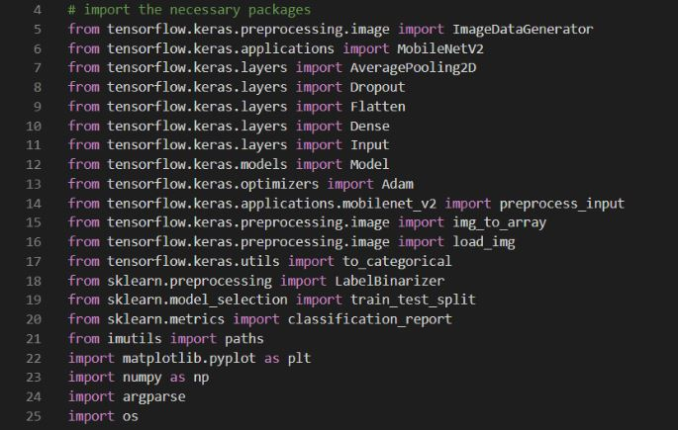

FIG.11: MASK DETECTOR MODEL

At first we need to import all the necessary packages into the python file. Packages we need are shown above.

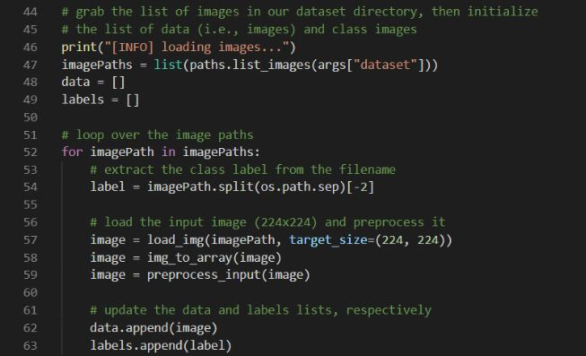

FIG.12: SETTING DIRECTORIES AND CATEGORIES AND LOOPING THEM

Here we can see my index is determined to my C drive containing Face-Mask-Detection organizer. Besides, inside the DIRECTORY, I referenced where my dataset organizer is available. In this way, machine can comprehend the dataset it need to use to run the program. Inside CATGORIES, I have referenced the qualities named with_mask and without_mask. These are additionally the organizers present in the DIRECTORY.

Here I have made two void records called 'information' and 'marks'. Afterward, I annexed the whole pictures exhibit into this 'information' list. Inside the 'mark' list I attached the name of those pictures whether it is with cover or without veil.

From that point onward, I have circled through the CATAGORIES by utilizing for order. By 'os.path.join' order I attempted to initially circle through the with veil and afterward through the without cover. At that point I recorded down every one of the pictures into the specific by utilizing 'listdir' order. At that point I stacked pictures utilizing the preprocessing capacity 'load_img' of the bundle 'keras' I have imported already. I gave the pictures an objective size of (224, 224) which is the stature and width of the pictures I needed to be. At that point I changed over every one of the pictures into exhibit by utilizing another 'keras' work called 'img_to_array'. I have utilized the 'mobiletnet' capacity of the bundle called 'tensorflow'. That is the reason I utilized 'preprocess_input' work here.

In the wake of preprocessing the pictures effectively, I added the pictures into the recently made 'information' rundown and classification into the 'marks' list.

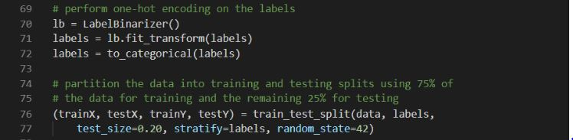

FIG.13: ENCODING LABELS

Presently, the pictures are in mathematical qualities. Which is useful for machine to see without any problem. Consequently, I expected to change over the marks into mathematical worth moreover. For thet I have utilized 'LabelBinarizer' work from the bundle 'sklearn'. At that point I changed over the 'names' contain with_mask and without_mask values into downright. It changed over the names into mathematical worth.

Subsequent to changing over both the rundowns into mathematical worth, I changed over both the rundowns into 'np' exhibit. Since profound learning models just work in exhibit design.

At that point I utilized 'train_test_split' to part my preparation and testing information. Here the test_size is 0.20, which demonstrates I have given 20% of the pictures for testing reason and the rest 80% for the preparation reason. It is in every case great to give more information for preparing reason to get a decent test outcome. I have utilized define into marks which is only characterize the names and the random_state shows the arrangement of train and test split I am getting. It really doesn't make any difference what number is this. It doesn't influence much on the split. In the event that I give 'none' in the random_state, it will simply pick a number arbitrarily to choose the parting of train and test files.

* 1. **TRAIN MODEL**

To prepare the model I utilized convolutional neural organization with a slight change. To comprehend the change, we first need to comprehend convolutional neural organization (CNN) model.

I have utilized MobileNet a rendition of ConvNet on the grounds that MobileNet is quicker than ConvNet as it utilizes profundity astute distinguishable convolution. Thus, it utilizes less boundary. That is the reason MobileNet is less precise as well. In any case, in my situation, utilizing MobileNet didn't have a much effect in result.

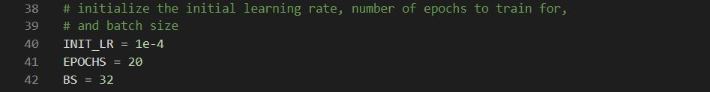

FIG.14: SETTING INITIAL LEARNING RATE, EPOCHS AND BATCH SIZE

Here, I have given INIT_LR as 1e^(- 4). It is the learning pace of my task. Kepping learning rate less assists with computing the misfortune appropriately. By this improving precision is a lot simpler. I have likewise give 20 EPOCHS and my cluster size is 32.

I recently referenced that I have utilized MobileNet which will produce two models. One is the MobileNet model and the yield of this model will make a standard model that I have

created. These models are called as Headmodel and Basemodel in my task.

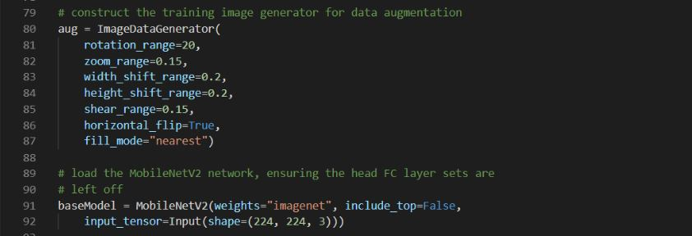

FIG.15: DATA AUGMENTATION AND CREATING BASE MODEL

Here, I have utilized 'ImageDataGenerator'. It really make numerous pictures from one single picture by changing a portion of the properties. It has numerous functionalities like moving picture, pivoting picture, flipping picture, zooming picture and so forth Here I have changed a few properties as demonstrated in the figure above.

Additionally, I have stacked the 'MobileNetV2' for making the models as recently referenced. Here, I referenced the loads, include_top, input_tensor and state of the information sources. By this I have made my baseModel.

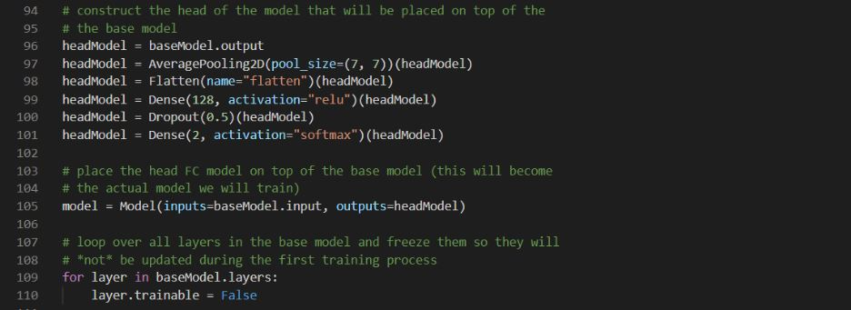

FIG.16: CREATING HEAD MODEL AND LOOPING BASED MODEL

In the wake of making my baseModel, I made my headModel. As recently told, headModel will be made utilizing the yield of baseModel, I have passed the baseModel yield into headModel. At that point I have made the pooling by utilizing 'AveragePooling2D' work. The size of pooling is 7/7 here. At that point I have added Flatten to the layer and a Dense layer utilizing 128 neurons and my actuation layer is 'relu' here. Relu is utilized for non-direct model like mine. To keep away from the overfitting I have utilized Dropout. At last, I have made my headModel with two layers (with veil and without cover) and softmax as my initiation esteem as softmax is the best fit for parallel models.

Presently I called the model capacity. As already notice baseModel is the info model and headModel is the yield model. I have frozen the baseModel by utilizing for circle. Since I have quite recently utilized baseModel rather than CNN and to keep it from running in the preparation.

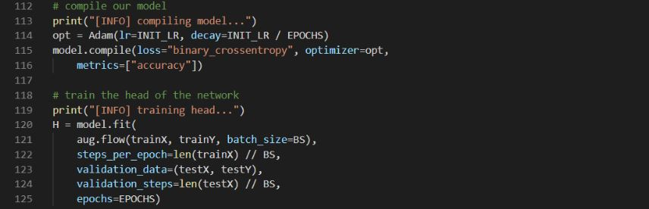

FIG.17: COMPILING HEAD AND BASE MODEL AND FITTING THE MODEL

At the point when both the models are prepared, I expected to gather the models by giving them my underlying learning rate, ADAM optimimizer (a got to streamlining agent) and following the exactness measurements.

At that point I expected to accommodate my model. For this, I have flown the Image Data Generator I have recently used to get really preparing information to prepare the pic

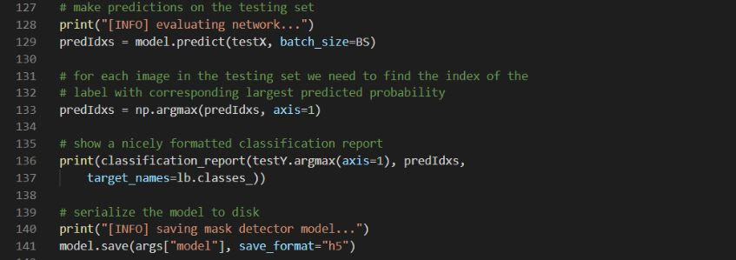

FIG.18: MAKING PREDICTIONS ON THE TESTING SET

Subsequent to ordering the model and preparing the head, I expected to assess the organization to make expectation to test the set. I have utilized 'model.predict' capacity to assess the organization. I additionally expected to discover the record for each picture. For that, I have utilized 'np.argmax' work. At that point I made capacity to get the arrangement report and to save the model record into the circle.

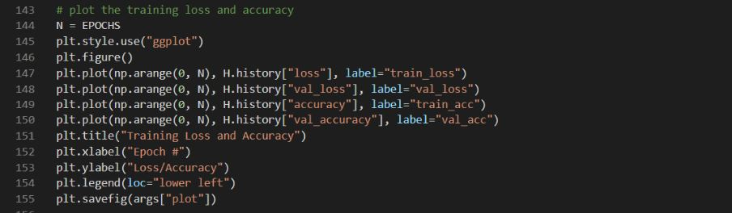

FIG.19: DEVELOPING CODES TO PLOT MODEL

Presently I have made capacity to plot the precision and loss of my model by utilizing MATPLOTLIB.

**3.4 IMPLEMENTATION**

**3.4.1 IMPLEMENTING OUR FACE MASK DETECTOR TRAINING SCRIPT**

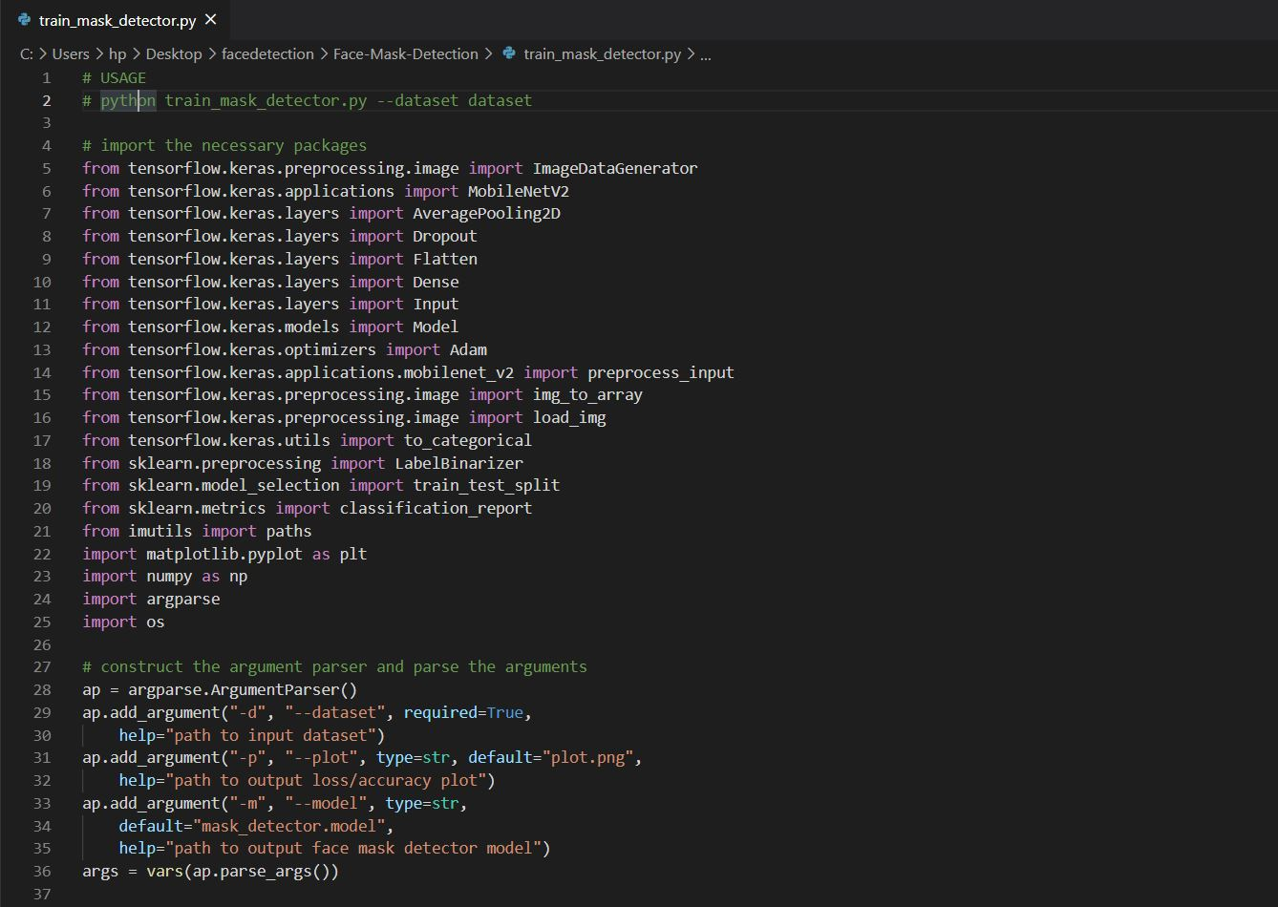

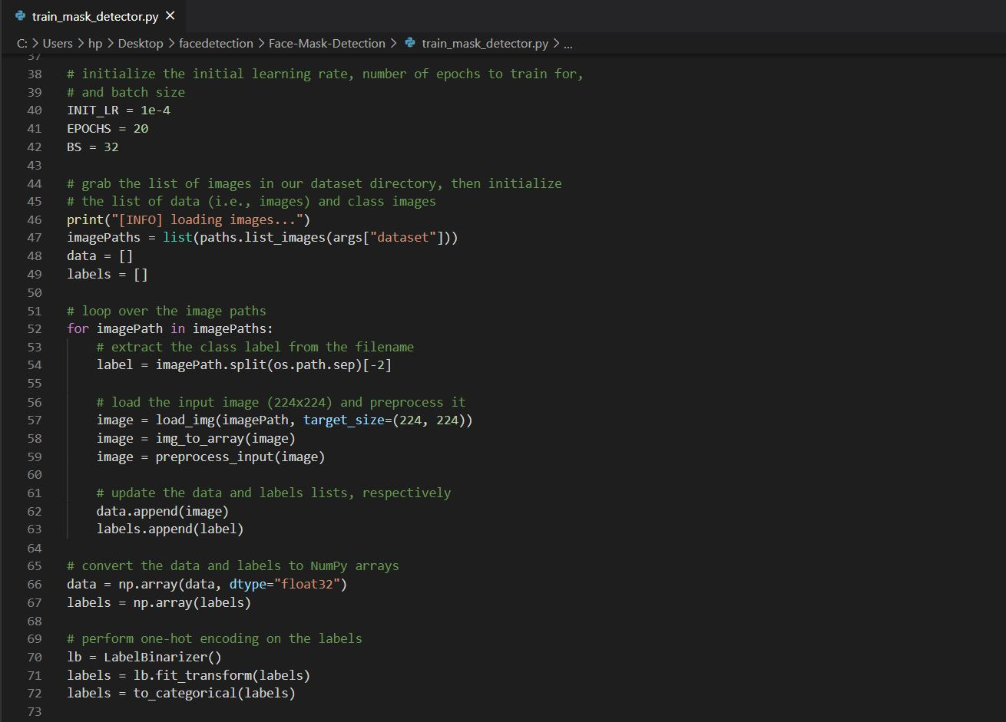

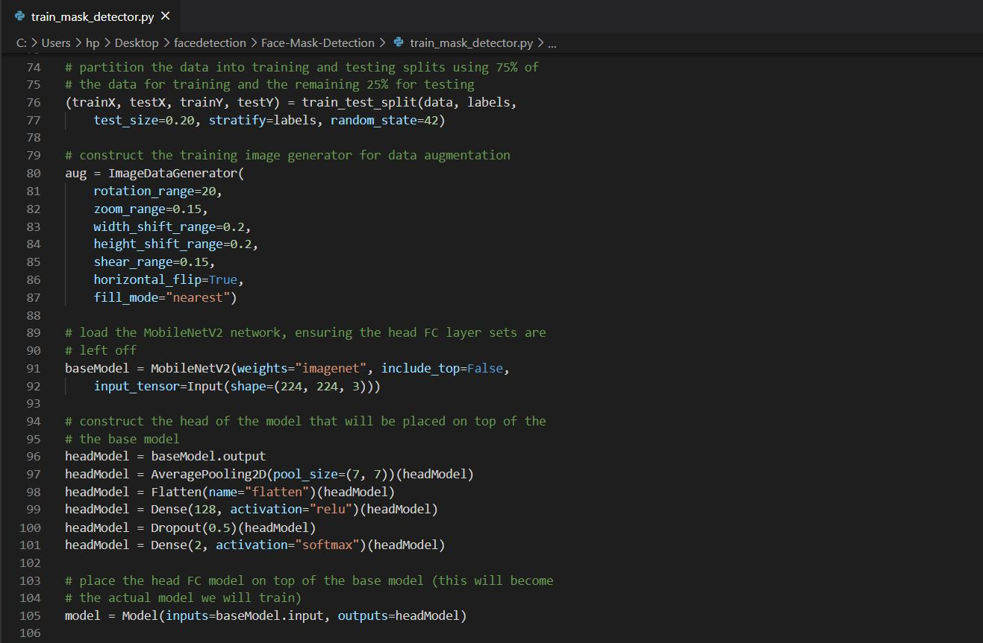

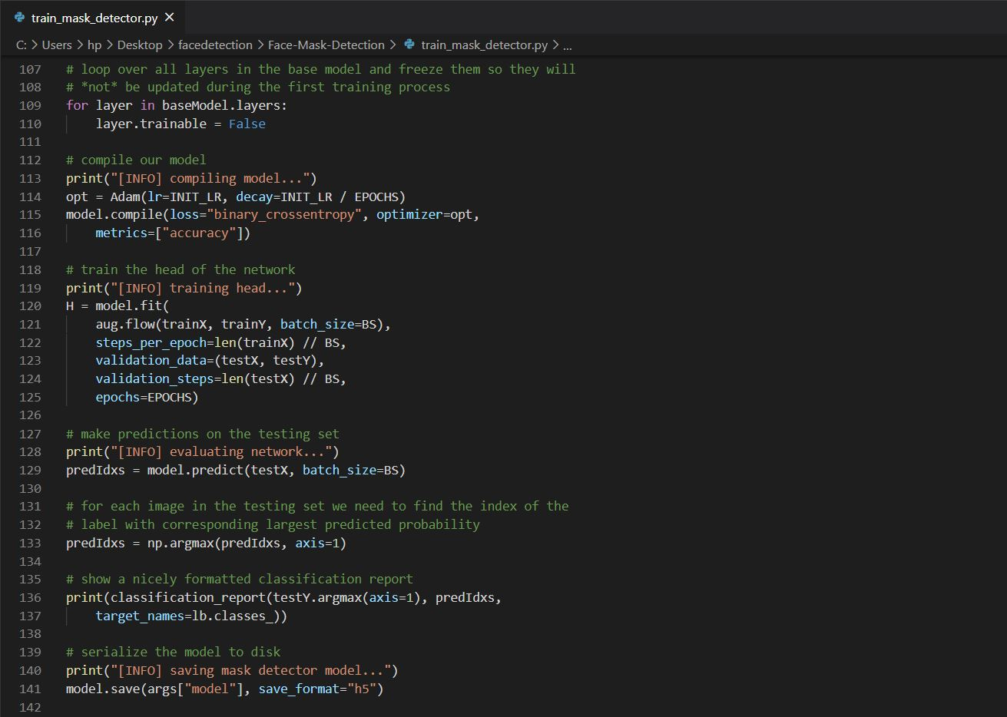

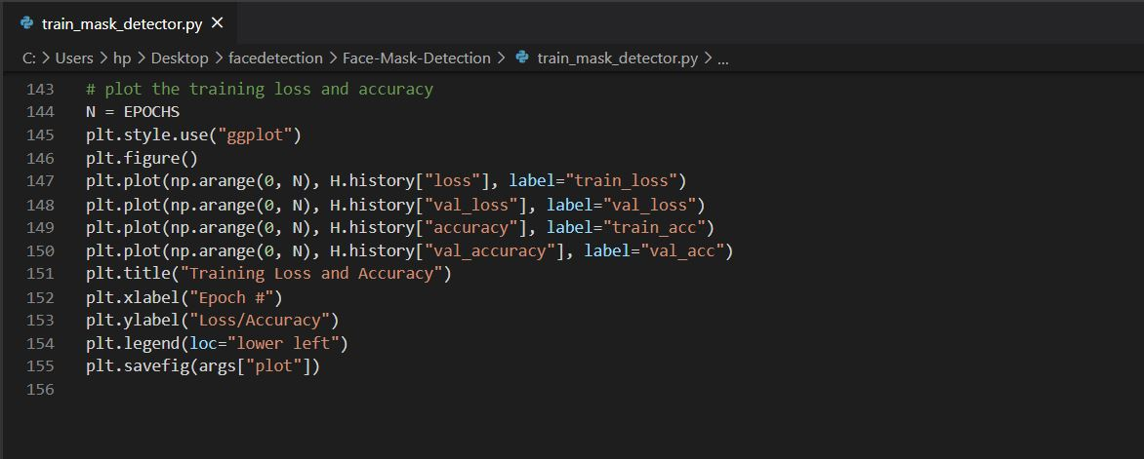

**3.4.2 IMPLEMENTING OUR FACE MASK DETECTOR FOR IMAGES WITH OPENCV**

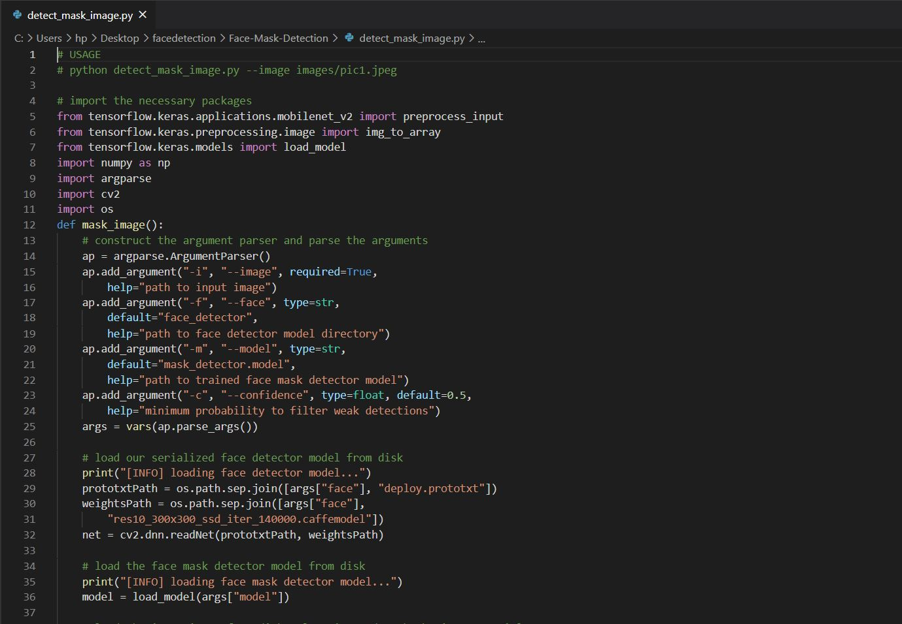

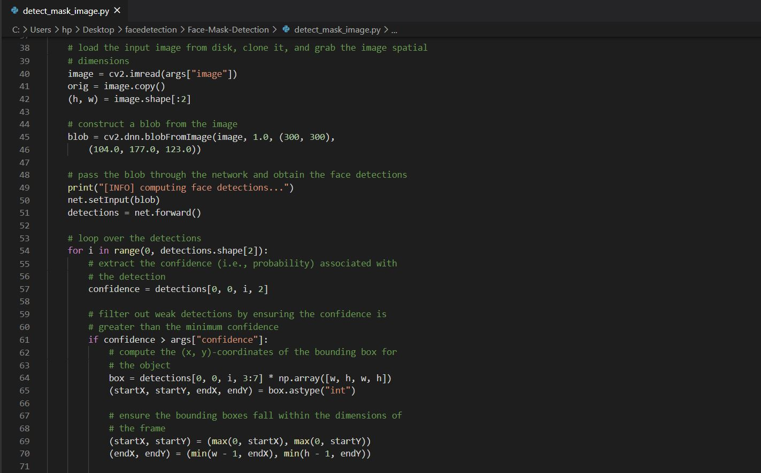

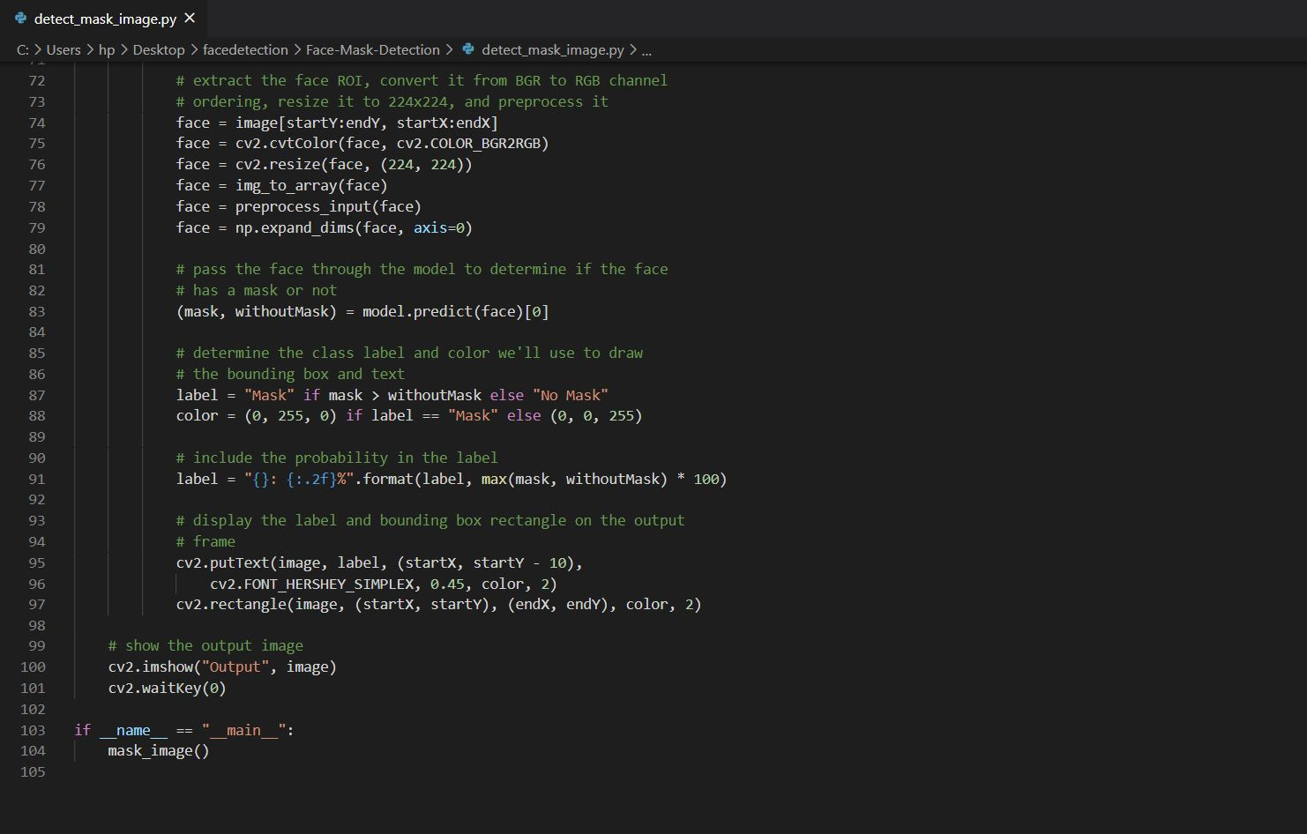

**3.4.3 IMPLEMENTING OUR FACE MASK DETECTOR IN REAL-TIME VIDEO STREAMS WITH OPENCV**

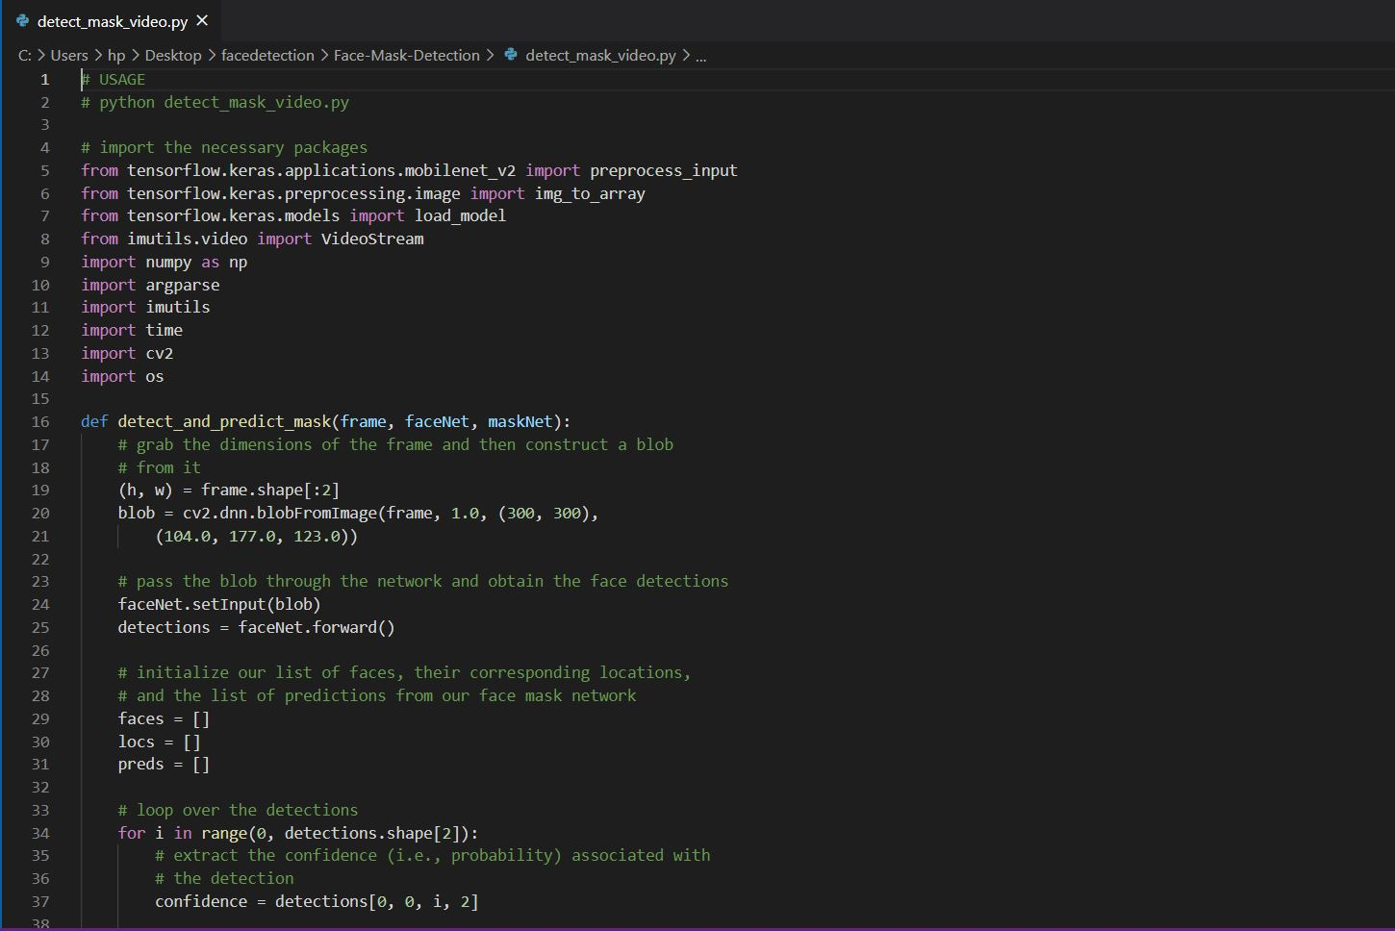

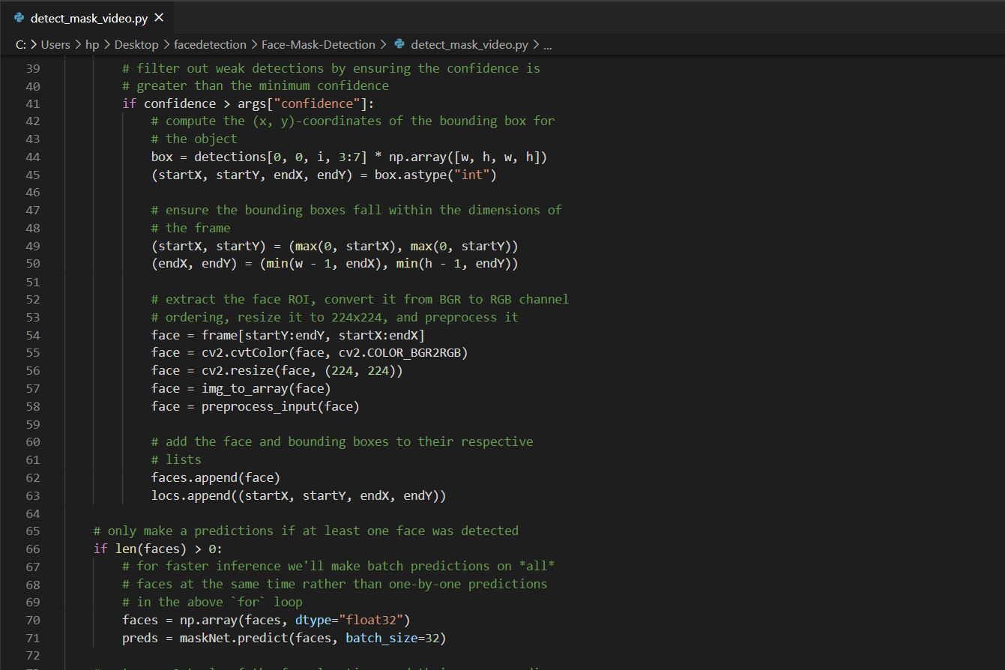

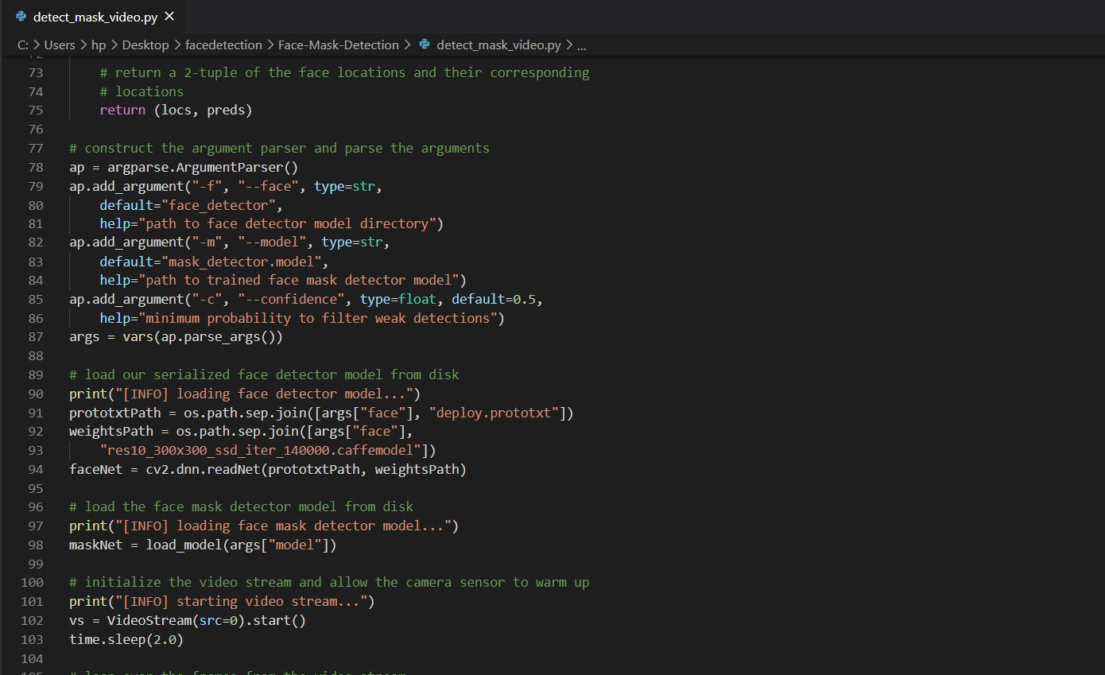

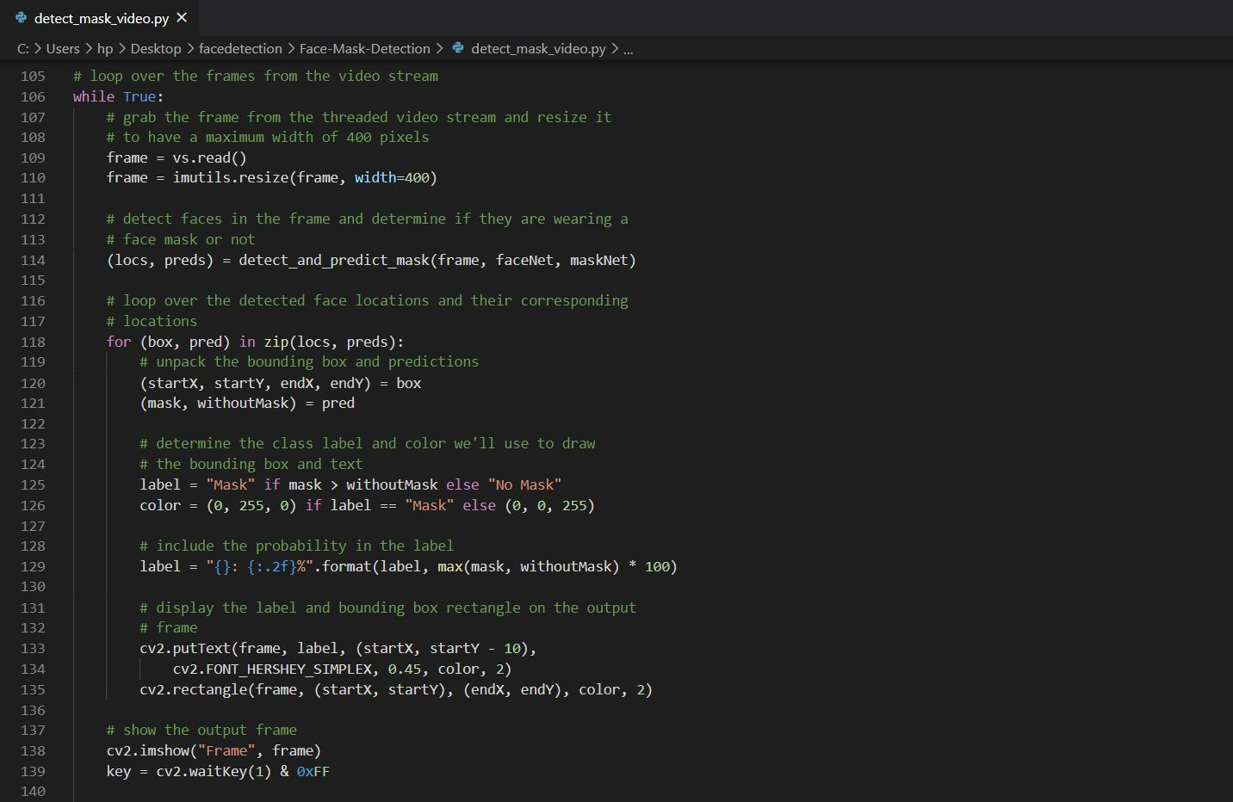

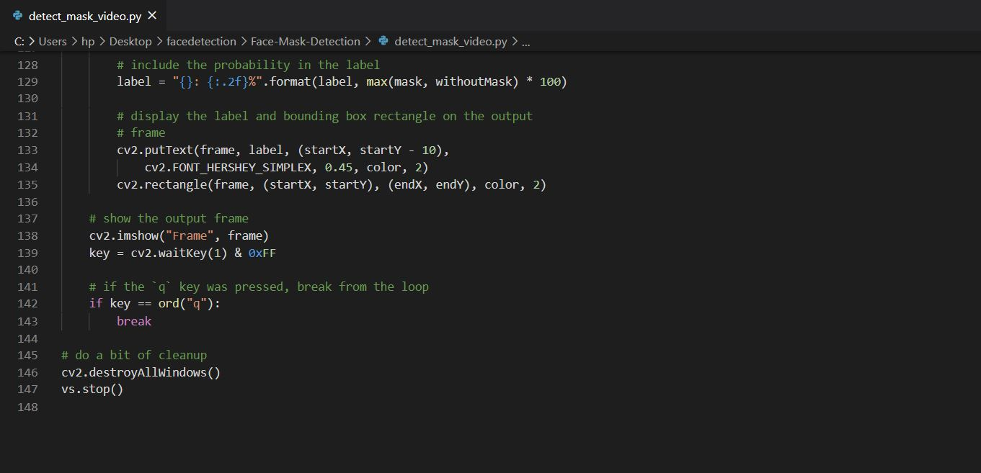

**3.5 RESULT**

**3.5.1 EXPERIMENTAL RESULT**

The experimental result of system performance are evaluated with the MobileNetV2 classifier and ADAM optimizer.

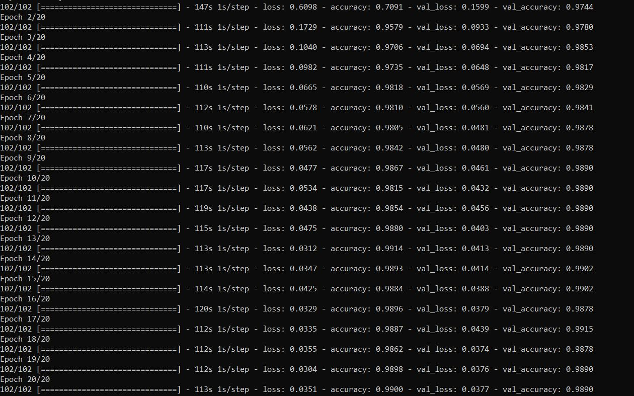

FIG.20:COMPILATION SCREEN FOR TRAINING_SCRIPT OF FACE MASK DETECTION

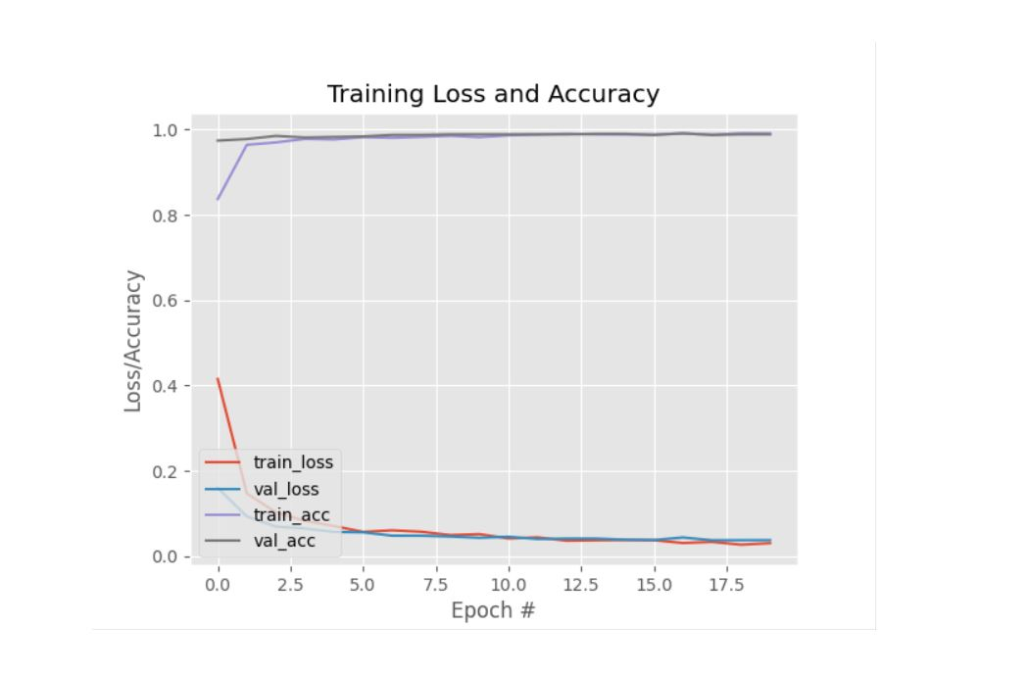

FIG.21**:**TRAINING LOSS/ACCURACY CURVES OF FACE MASK DETECTION DATASET

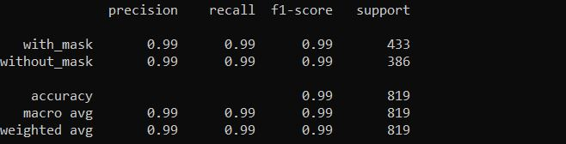

FIG.22**:** FACE MASK CLASSIFIER PERFORMANCE METRICS

**3.6 FINAL RESULT**

Joining every one of the components of our engineering, we will in general so get right cover perception situation. MobileNetV2 classifier utilized in this framework. The resultant framework execution and can possibly distinguish face veil in picture with numerous face over a huge shift points.

**FACE MASK DETECTION FROM IMAGE:**

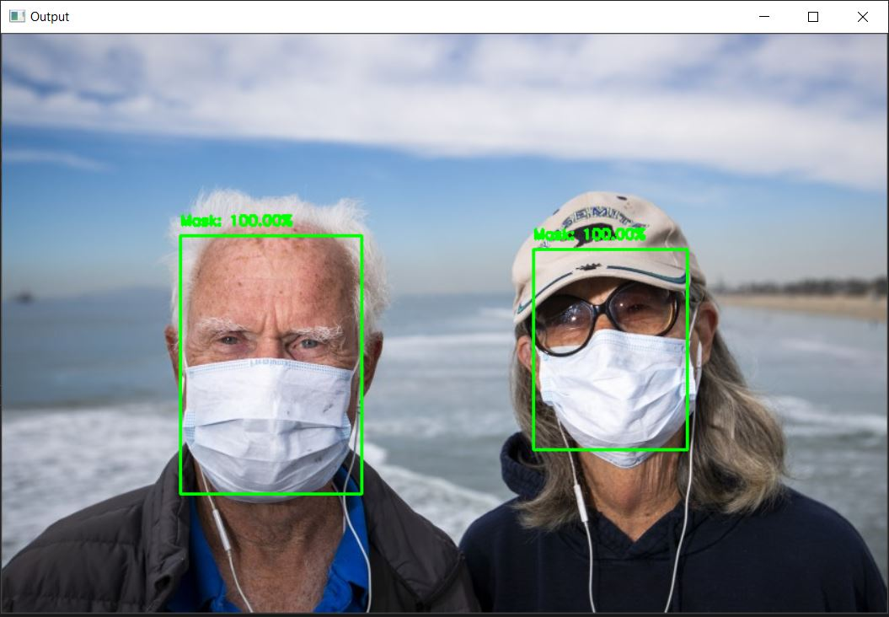

FIG.23: DETECT FACE WITH MASK IN IMAGE

**FACE MASK DETECTION FROM REAL TIME IMAGE:**

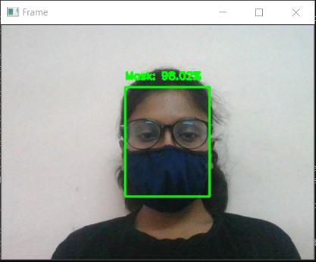

FIG.24: DETECT FACE WITH MASK IN REAL TIME VIDEO STREAM

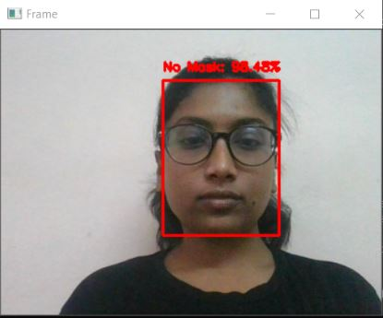

FIG.25: DETECT FACE WITHOUT MASK IN REAL TIME VIDEO STREAM

1. **FINDING, CONCLUSION AND RECOMMENDATIONS**

**4.1 CONCLUSION:**

Coronavirus pandemic causes such a lot of death and answerable for worldwide wellbeing emergency. The world is as yet attempting to forestall the circumstance and escape the worldwide emergency. Each nation is attempting in its own specific manner. Notwithstanding, the present circumstance is so hard to control. In the present condition, model like this may be a gift for some nations. Utilizing customary AI strategies, this kind of task can be created in a bigger manner. The focal point of this undertaking was to make a model of a Face-Mask Detector that may assist with building up a genuine task dependent on my venture. I attempted to accomplish most elevated precision conceivable by me in the model. By this task, we can comprehend things identified with Machine Learning and Artificial Intelligence. Additionally, we can find out about the python instruments to grow such venture. The principle objective was to adapt profoundly about how profound learning functions. Also, this undertaking may help different scientists who may chip away at related task. Eventually, I can say that the objective of making this task is completely used and accomplished.

**4.2 RECOMMENDATIONS:**

I confronted a few constraints finishing this undertaking. From these downsides, future specialists can get familiar with a ton. What's more, I concoct a few proposals for future scientists from my experience finishing this task.

* If potential, analysts could utilize a bigger dataset to get more precise resullt.
* Learn profoundly about the python programming language and its utilization.
* Learn increasingly more about profound learning, a sub space of AI.
* Increase information about convolutional neural organization, will assist a great deal with getting higher exactness model.
* Use ConvNet rather than MobileNet if conceivable to accomplish better outcome.

1. **APPENDIX AND BIBLIOGRAPHY**

**5.1 REFERENCES**

1. Mask, F., & Using, D. (2021). *Report on*.
2. S, K. S. D., Rengarajan, A., & S, N. K. H. (2020). *DETECTING OF FACE MASK*. *12*, 132–134.
3. Nagoriya, H., & Parekh, M. (2020). *Live Facemask Detection System*. *December*. https://doi.org/10.13140/RG.2.2.22178.04804
4. Moein Razavi, Hamed Alikhani, Vahid Janfaza, Benyamin Sadeghi, & Ehsan Alikhani. (2021). *An Automatic System to Monitor the Physical Distance and Face Mask Wearing of construction Workers in COVID-19 Pandemic*. 7. https://arxiv.org/abs/2101.01373
5. Bhadani, A. K., & Sinha, A. (2020). A Facemask Detector using Machine Learning and Image Processing Techniques. *Engineering Science and Technology , an International Journal*, *November*, 0–8. https://www.researchgate.net/publication/345972030_A_FACEMASK_DETECTOR_USING_MACHINE_LEARNING_AND_IMAGE_PROCESSING_TECHNIQUES
6. <https://www.tensorflow.org/>
7. <https://keras.io/about/>
8. <https://pypi.org/project/imutils/>
9. <https://numpy.org/>
10. <https://opencv.org/about/>
11. <https://pypi.org/project/matplotlib/>
12. <https://en.wikipedia.org/wiki/SciPy>
13. <https://paperswithcode.com/method/mobilenetv2>
14. Sung, K. K., & Poggio, T. (1998). Example-based learning for view-based human face detection. *IEEE Transactions on pattern analysis and machine intelligence, 20(1)*, 39-51.
15. Albawi, S., Mohammed, T. A., & Al-Zawi, S. (2017, August). Understanding of a convolutional neural network. *In 2017 International Conference on Engineering and Technology (ICET). IEEE.*, 1-6.
16. B. QIN and D. Li, Identifying facemask-wearing condition using image super-resolution with classification network to prevent COVID-19, May 2020, doi: 10.21203/rs.3.rs-28668/v1.
17. C. Li, R. Wang, J. Li, L. Fei, Face detection based on YOLOv3, in:: Recent Trends in Intelligent Computing, Communication and Devices, Singapore, 2020, pp. 277–284, doi: 10.1007/978-981-13-9406-5_34.
18. Yadav, S. Deep Learning based Safe Social Distancing and Face Mask Detection in Public Areas for COVID-19 Safety Guidelines Adherence.
19. Chowdary, G. J., Punn, N. S., Sonbhadra, S. K., & Agarwal, S. (2020). Face Mask Detection using Transfer Learning of InceptionV3. arXiv preprint arXiv:2009.08369.Smith, B. S. and Carter, C. (1969). A method of analysis for infilled frames, Proceedings of the Institution of Civil Engineers, Vol.7218, 31-48.
20. Militante, S. V., & Dionisio, N. V. (2020, August). Real-Time Facemask Recognition with Alarm System
21. van, R. G., & de Boer, J. (1991). Interactively testing remote servers using the Python programming language. *CWi Quarterly, 4(4)*, 283-303.
22. S., B. (2020, July 9). *balajisrinivas*. Retrieved from Github: <https://github.com/balajisrinivas/Face-Mask-Detection>
23. Adam: A Method for Stochastic Optimization - Diederik P. Kingma, Jimmy Ba
24. Vinitha.V1, Velantina.V2. COVID-19 FACEMASK DETECTION WITH DEEP LEARNING AND COMPUTER VISION.
25. Proximal and First-Order Methods for Convex Optimization - John C. Duchi Yoram Singer